**Project Object Oriented Visual Programming**

**Movie Ticket Management Java Application**



# COVER

**Name : Abdurrahman Khairi**

**PU ID : 001202300163**

**Class : Informatics 4**

**Lecturer :**

**Ms. Deffa Rahadian**

**MAJOR INFORMATICS**

**FACULTY COMPUTING**

**PRESIDENT UNIVERSITY**

**ACADEMIC YEAR 2023/2024**

# TABLE OF CONTENTS

COVER i

TABLE OF CONTENTS ii

TABLE OF IMAGES iv

BAB I INTRODUCTION 1

1.1 BACKGROUND 1

1.2 PROBLEM STATEMENT 1

1.3 OBJECTIVE 2

e. PROJECT BENEFITS 3

f. APPLICATION 4

g. LINK APPLICATION 4

BAB II THEORITICAL FRAMEWORK 5

2.1 JAVA NETBEANS 5

2.1.1 Rationale for Selecting Java NetBeans 5

2.1.2 Key Advantages of Java NetBeans 5

2.1.3 Specific Features of NetBeans IDE 21 6

2.1.4 MySQL Connector 8.0.25 Integration 6

2.2 DATABASE CONNECTION 7

2.2.1 AdminUser 7

2.2.2 NormalUser 10

2.2.3 BannedUser 13

2.2.4 MovieDetails 15

2.2.5 MovieRequest 19

BAB III OBJECT ORIENTED PROGRAMMING PILLARS 22

3.1 ENCAPSULATION 22

3.2 INHERITANCE 24

3.3 POLYMORPHISM 26

3.4 ABSTRACTION 27

BAB IV SYSTEM DESIGN 28

4.1 MAIN APPLICATION 28

4.2 ADMIN 29

4.2.1 adminLogin 29

4.2.2 adminForm 31

4.2.3 addAdmin 32

4.2.4 RemoveAdmin 35

4.2.5 BanUser 37

4.2.6 addMovie 39

4.2.7 editMovie 41

4.2.8 deleteMovie 44

4.2.9 requestedMovie 46

4.2.10 logOutAdmin 47

4.3 USER 48

4.3.1 UserLogin 48

4.3.2 RegisterUser 49

4.3.3 UserForm 51

4.3.4 AllMovie 52

4.3.5 AddReview 54

4.3.6 SearchMovie 56

4.3.7 ContactUs 62

4.3.8 RequestMovie 63

4.3.9 LogOutUser 65

BAB V CONCLUSION 66

5.1 CONCLUSION 66

5.2 BENEFITS 66

5.3 FUTURE RECOMMENDATION 67

# TABLE OF IMAGES

Image 2.2.1.1 mySQL Code Table AdminUser 7

Image 2.2.1.2 Database Table AdminUser 7

Image 2.2.1.3 Database Connection Insert Admin or Normal User 7

Image 2.2.1.4 Database Connection Admin or Normal Exist 8

Image 2.2.1.5 Database Connection Validation Admin or Normal User 8

Image 2.2.1.6 Database Connection Delete Admin or Normal User 9

Image 2.2.2.1 mySQL Code Database Table NormalUser 10

Image 2.2.2.2 Database Table NormalUser 10

Image 2.2.3.1 mySQL Code Database Table BannedUser 13

Image 2.2.3.2 Database Table BannedUser 13

Image 2.2.3.3 Database Connection Add Banned User 13

Image 2.2.3.4 Database Connection Banned User 14

Image 2.2.4.1 mySQL Code Database Table MovieDetails 15

Image 2.2.4.2 Database Connection Table MovieDetails 15

Image 2.2.4.3 Database Connection Add Movie 15

Image 2.2.4.4 Database Connection Check Movie 16

Image 2.2.4.5 Database Connection Delete Movie and Request 16

Image 2.2.4.6 Database Connection Get Show Movie 17

Image 2.2.4.7 Database Connection Get Show Genre or Director 17

Image 2.2.4.8 Database Connection Get Show Rating 18

Image 2.2.5.1 mySQL Code Database Table MovieRequest 19

Image 2.2.5.2 Database Table MovieRequest 19

Image 2.2.5.3 Database Connection Add Request Movie 19

Image 2.2.5.4 Database Connection Movie Request Exist 20

Image 2.2.5.5 Database Connection Delete Movie or Request Movie 20

Image 2.2.5.6 Database Connection Get Show Requested Movie 21

Image 3.1.1 Encapsulation 22

Image 3.2.1 Inheritance 24

Image 3.3.1 Polymorphism 26

Image 3.4.1 Abstraction 27

Image 4.1.1 Main Display Application 28

Image 4.2.1.1 Image View Admin Login Form 29

Image 4.2.1.2 Input Admin Form 29

Image 4.2.1.3 Wrong Login Admin Form 30

Image 4.2.2.1 Image Login Admin Form 31

Image 4.2.2.2 View Admin Form 31

Image 4.2.3.1 Form Add Admin 32

Image 4.2.3.2 Input Add Admin Form 32

Image 4.2.3.3 Username and Password Required 33

Image 4.2.3.4 Username and Password Too Short 33

Image 4.2.3.5 Username and Password Too Long 34

Image 4.2.3.6 Admin Added Successfully 34

Image 4.2.3. 7 View Remove Admin Form 35

Image 4.2.4.1 View Remove Admin Form 35

Image 4.2.4.2 Input Remove Admin Form 35

Image 4.2.4.3 Cancel Remove Admin 36

Image 4.2.4.4 Admin Removed Successfully 36

Image 4.2.5.1 Database Table BannedUser 13

Image 4.2.5.2 View Ban User Form 37

Image 4.2.5.3 Input Ban User Form 37

Image 4.2.5.4 Cancel Ban User Form 38

Image 4.2.5.5 Banned User 38

Image 4.2.6.1 View Add Movie Form 39

Image 4.2.6.2 Input Add Movie Form 39

Image 4.2.6.3 Cancel Add View Form 40

Image 4.2.6.4 Movie Added Successfully 40

Image 4.2.7.1 View Edit Movie Form 41

Image 4.2.7.2 Input Edit Movie Form 41

Image 4.2.7.3 Cancel Edit Movie Form 42

Image 4.2.7.4 View Update Movie Form 42

Image 4.2.7.5 Movie Updated Successfully 43

Image 4.2.8.1 View Delete Movie Form 44

Image 4.2.8.2 Input Delete Movie Form 44

Image 4.2.8.3 Cancel Delete Movie Form 45

Image 4.2.8.4 Movie Deleted Successfully 45

Image 4.2.9.1 View First Requested Movie 46

Image 4.2.9.2 View Last Request Movie 46

Image 4.2.10.1 LogOut Admin 47

Image 4.3.1.1 View LogIn User Form 48

Image 4.3.1.2 Input Login User Form 48

Image 4.3.2.1 View Regiestration User Form 49

Image 4.3.2.2 Input Registration User Form 49

Image 4.3.2.3 Registration User Successfully 50

Image 4.3.3.1 LogIn User Form 51

Image 4.3.3.2 View User Form 51

Image 4.3.4.1 View Display All Movie Details 52

Image 4.3.4.2 View First Movie Details 52

Image 4.3.4.3 View Last Movie Details 53

Image 4.3.5.1 View Add Review Form 54

Image 4.3.5.2 Input Add Review Form 54

Image 4.3.5.3 Review Added Successfully 55

Image 4.3.6.1 View Search Movie Form 56

Image 4.3.6.2 View Serch Movie By Name Form 56

Image 4.3.6.3 Input Serach Movie By Name Form 57

Image 4.3.6.4 Display Movie Details By Searching Name Form 57

Image 4.3.6.5 View Search Movie By Genre Form 58

Image 4.3.6.6 Display Movie Details By Seaching Genre Form 58

Image 4.3.6.7 View Search Movie By Director Form 59

Image 4.3.6.8 Input Search Movie By Director Form 59

Image 4.3.6.9 Display Movie Details By Searching Director Form 60

Image 4.3.6.10 View Search Movie By Rating Form 60

Image 4.3.6.11 Input Search Movie By Rating Form 61

Image 4.3.6.12 Display Movie Details By Searching Rating Form 61

Image 4.3.7.1 View Contact Us 62

Image 4.3.8.1 View Request Movie Form 63

Image 4.3.8.2 Input Request Movie Form 63

Image 4.3.8.3 Request Send Successfully 64

Image 4.3.8.4 LogOut User 65

# BAB I INTRODUCTION

## BACKGROUND

In today's dynamic world, where time is a precious commodity, the demand for efficient and convenient solutions has permeated every aspect of our lives. The entertainment industry, particularly the world of cinema, is no exception to this trend. Movie enthusiasts eagerly seek seamless and hassle-free ways to indulge in their passion for captivating cinematic experiences.

However, the traditional methods of movie ticket booking often fall short of meeting these expectations. The manual process of purchasing tickets at cinema counters can be time-consuming and inconvenient, often leading to long queues and frustration among eager moviegoers. Additionally, the lack of comprehensive and readily available movie information on traditional ticketing platforms often leaves users struggling to make informed decisions about their cinematic choices.

To address these shortcomings and elevate the movie-watching experience, innovative solutions are urgently needed. The development of a user-friendly, informative, and feature-rich movie ticketing application has emerged as a promising approach to revolutionize the way we access and enjoy the magic of cinema.

## PROBLEM STATEMENT

The current movie ticketing landscape is plagued by several fundamental issues that hinder the overall user experience:

1. **Manual Booking System:** The archaic process of purchasing movie tickets manually at cinema counters remains a significant inconvenience, often resulting in lengthy queues
2. and wasted time for movie enthusiasts. This outdated system fails to align with the fast-paced nature of modern life, where efficiency and convenience are paramount.
3. **Lack of Comprehensive Movie Information:** Traditional ticketing platforms often lack the depth and breadth of movie information that users seek to make informed decisions about their cinematic choices. Essential details such as synopses, trailers, ratings, and user reviews are often scarce or inaccessible, leaving users with limited insights into the films they consider watching.
4. **Limited Movie Selection:** The range of movies available on traditional ticketing platforms often falls short of meeting the diverse preferences of moviegoers. The lack of variety restricts users' options and hinders their ability to discover films that align with their interests and tastes.

These challenges collectively create a frustrating and unsatisfactory experience for movie enthusiasts, diminishing the overall enjoyment of their cinematic endeavors.

## OBJECTIVE

Driven by the desire to transform the movie-watching experience, this project aims to develop a user-friendly, informative, and feature-rich movie ticketing application that addresses the shortcomings of traditional ticketing methods. The application will empower users to seamlessly book tickets, access comprehensive movie information, and discover a diverse range of films. Here's a breakdown of the key objectives:

1. **Simplify Movie Ticket Booking:** The application will streamline the ticket booking process, enabling users to purchase tickets quickly and conveniently.
2. **Enhance Movie Information Accessibility:** Provide users with detailed synopses, trailers, ratings, and reviews to make informed choices.
3. **Expand Movie Selection:** Offer a vast selection of movies from various genres and countries, catering to diverse preferences.
4. **Increase User Convenience and Satisfaction:** Ultimately, create a seamless and enjoyable movie-watching experience through streamlined booking, rich information, and diverse film choices.

## PROJECT BENEFITS

The implementation of this innovative movie ticketing application will bring forth a multitude of benefits for users, including:

1. **Simplified Movie Ticket Booking:** The application will streamline the ticket booking process, enabling users to purchase tickets quickly and conveniently from the comfort of their own devices. This eliminates the need for lengthy queues at cinema counters, saving users valuable time and effort.
2. **Comprehensive Movie Information:** The application will serve as a comprehensive resource for movie information, providing users with detailed synopses, engaging trailers, informative ratings, and insightful user reviews. This wealth of information will empower users to make informed decisions about their cinematic choices, ensuring they select films that align with their preferences and expectations.
3. **Wide Variety of Films:** The application will offer an extensive selection of movies from various genres and countries, catering to the diverse tastes and interests of movie enthusiasts. This wide array of choices will enable users to discover new films, explore different cinematic styles, and expand their horizons in the world of cinema.
4. **Enhanced User Convenience and Satisfaction:** By addressing the limitations of traditional ticketing methods, the application will significantly enhance user convenience and satisfaction. The streamlined booking process, comprehensive movie information, and diverse film selection will collectively create a seamless and enjoyable movie-watching experience for all users.

## APPLICATION

This versatile movie ticketing application will cater to a broad spectrum of users, including:

1. **Movie Enthusiasts:** Avid moviegoers who seek convenient and hassle-free ways to book tickets and access comprehensive movie information.
2. **Families:** Families seeking a fun and engaging way to enjoy movies together, with the ease of booking tickets and selecting films that appeal to all ages.
3. **Students:** Students on a budget who appreciate the convenience and affordability of booking tickets through the application.
4. **General Users:** Individuals who enjoy watching movies and appreciate the wide variety of films available on the application.

The application's accessibility across various devices, including smartphones, tablets, and computers, will further enhance its usability and broaden its reach, allowing users to access its features anytime, anywhere.

## LINK APPLICATION

Github :

https://github.com/abdurrahmankhairii/laravel_project.git

# BAB II THEORITICAL FRAMEWORK

## JAVA NETBEANS

### Rationale for Selecting Java NetBeans

The decision to utilize Java NetBeans as the primary development environment for this final project was driven by several compelling factors:

1. **Robustness and Versatility:** Java is a widely recognized and mature programming language renowned for its object-oriented paradigm, platform independence, and extensive security features. Its versatility makes it suitable for developing a wide range of applications, including complex enterprise systems.
2. **NetBeans IDE's Comprehensive Features:** NetBeans IDE offers a comprehensive suite of tools and functionalities that streamline the development process, enhancing productivity and efficiency. Its intuitive graphical user interface, code completion capabilities, and debugging tools significantly expedite the development cycle.
3. **Seamless Integration with MySQL Database:** MySQL is a popular open-source relational database management system known for its reliability, scalability, and ease of use. NetBeans IDE provides seamless integration with MySQL, enabling effortless data management and manipulation within the application.

### Key Advantages of Java NetBeans

The combination of Java and NetBeans IDE offers a multitude of advantages for developing this movie ticketing application:

1. **Simplified Development:** Java's object-oriented programming approach and NetBeans IDE's intuitive tools facilitate efficient coding and rapid prototyping.
2. **Robust Application:** Java's inherent security features and NetBeans IDE's debugging tools ensure the application's stability and reliability.
3. **Scalable Solution:** Java's scalability and NetBeans IDE's modular design enable the application to accommodate future growth and enhancements.
4. **Cross-Platform Compatibility:** Java's platform independence ensures the application runs seamlessly across various operating systems, expanding its reach.

### Specific Features of NetBeans IDE 21

NetBeans IDE 21 provides a plethora of features that significantly enhance the development experience:

1. **Intuitive Graphical User Interface:** The user-friendly interface simplifies navigation and access to development tools.
2. **Advanced Code Completion:** Intelligent code completion suggestions streamline coding and reduce errors.
3. **Refactoring Tools:** Powerful refactoring tools facilitate code restructuring and maintainability.
4. **Integrated Debugging Tools:** Comprehensive debugging tools aid in identifying and resolving software defects.
5. **Version Control Integration:** Seamless integration with version control systems like Git promotes collaboration and code management.

### MySQL Connector 8.0.25 Integration

MySQL Connector 8.0.25 plays a crucial role in enabling effective database interaction:

1. **Database Connectivity:** Establishes a robust connection between the application and the MySQL database.
2. **Data Manipulation:** Facilitates efficient data retrieval, insertion, updates, and deletions within the application.
3. **Database Administration:** Provides tools for managing database schema, users, and permissions.

## DATABASE CONNECTION

### AdminUser

1. 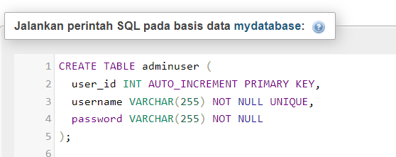MySQL Code

Image 2.2.1.1 mySQL Code Table AdminUser

1. 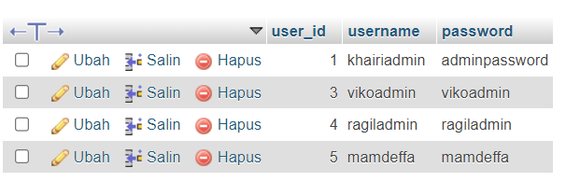MySQL Table

Image 2.2.1.2 Database Table AdminUser

1. 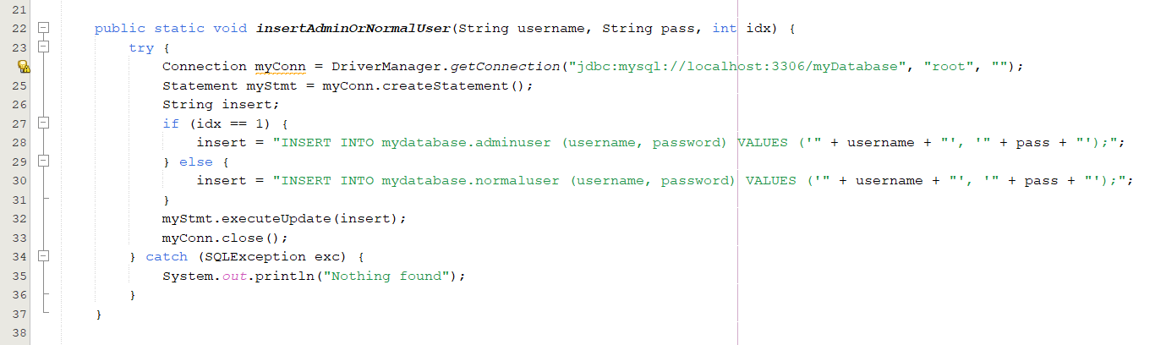Connection Java Netbeans

Image 2.2.1.3 Database Connection Insert Admin or Normal User

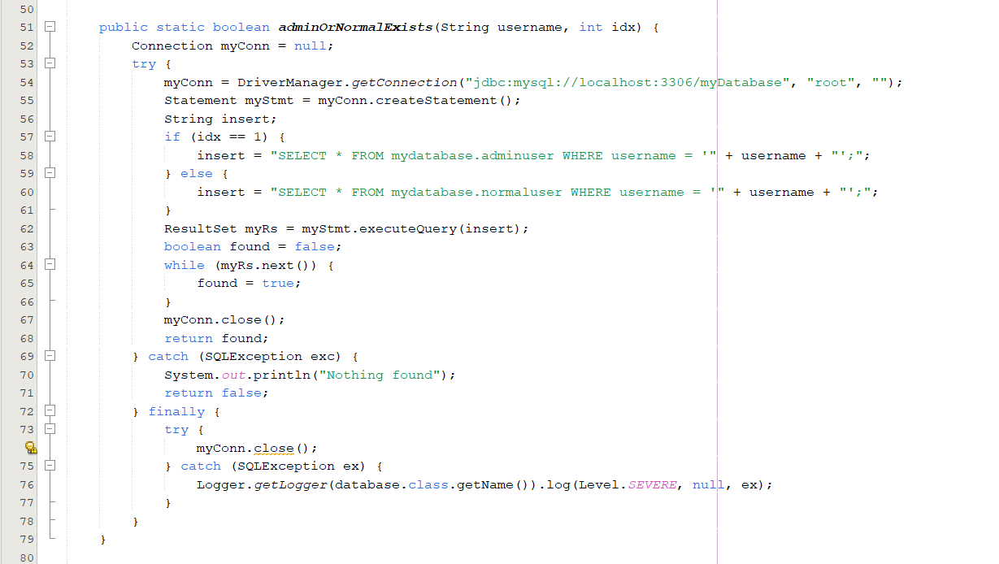

Image 2.2.1.4 Database Connection Admin or Normal Exist

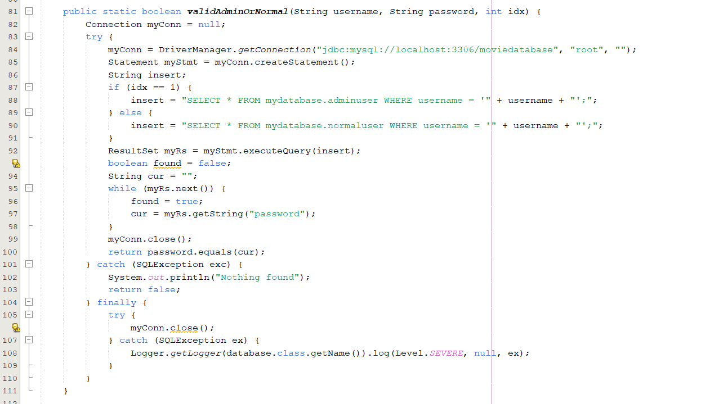

Image 2.2.1.5 Database Connection Validation Admin or Normal User

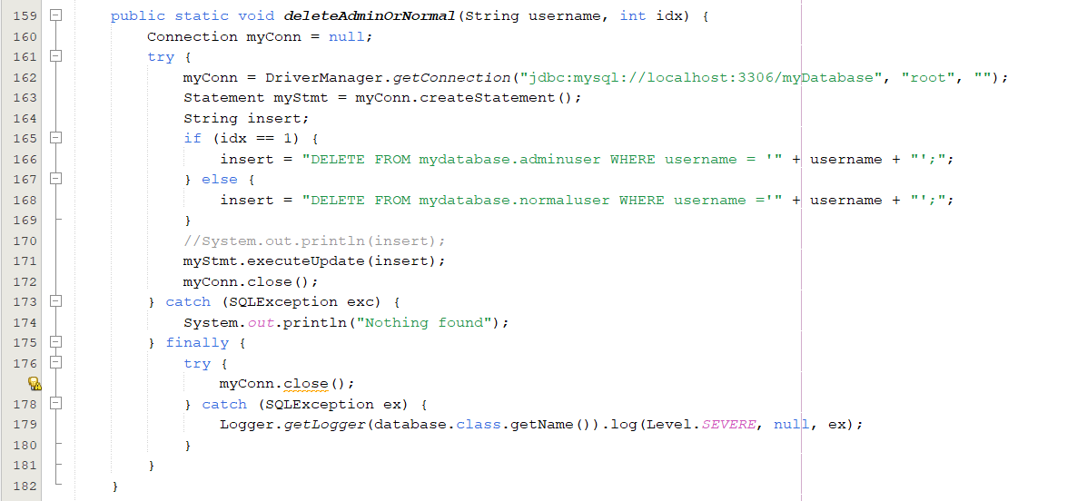

Image 2.2.1.6 Database Connection Delete Admin or Normal User

### NormalUser

1. 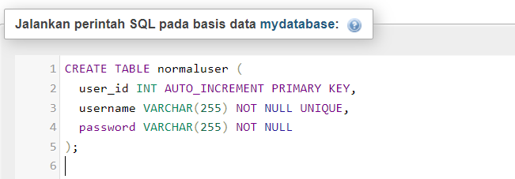MySQL Code

Image 2.2.2.1 mySQL Code Database Table NormalUser

1. 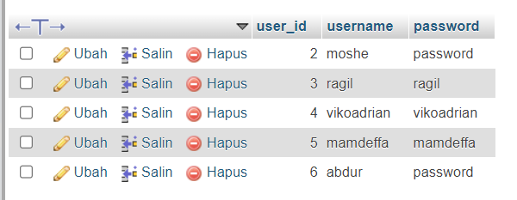MySQL Table

Image 2.2.2.2 Database Table NormalUser

1. Connection Java Netbeans

Image 2.2.2.7 Database Connection Insert Admin or Normal User



Image 2.2.2.8 Database Connection Admin or Normal Exist



Image 2.2.2.9 Database Connection Validation Admin or Normal User



Image 2.2.2.10 Database Connection Delete Admin or Normal User

### BannedUser

1. MySQL Code

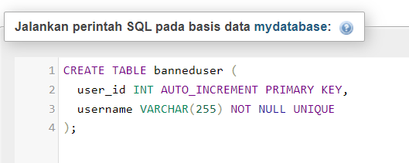

Image 2.2.3.1 mySQL Code Database Table BannedUser

1. 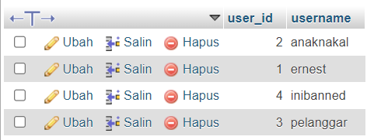MySQL Table

Image 4.2.5.1 Database Table BannedUser

Image 2.2.3.2 Database Table BannedUser

1. 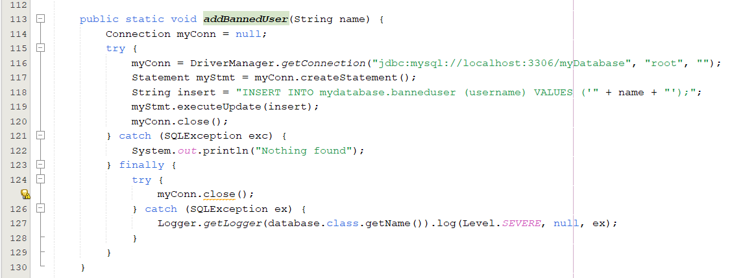Connection Java Netbeans

Image 2.2.3.3 Database Connection Add Banned User

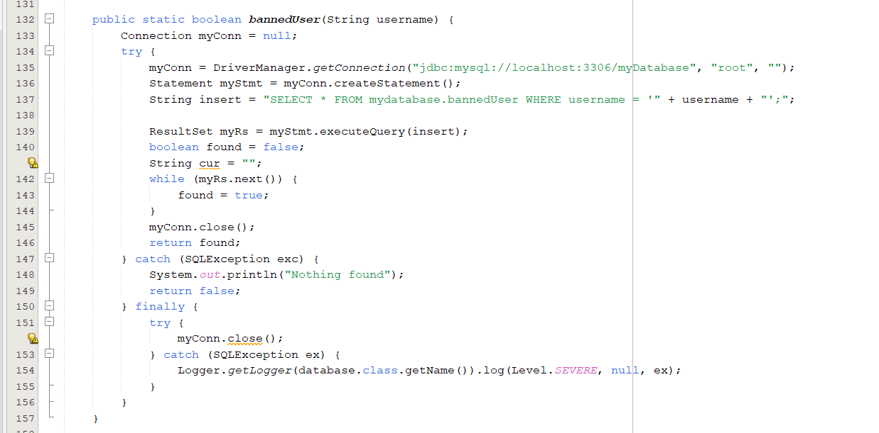

Image 2.2.3.4 Database Connection Banned User

### MovieDetails

1. 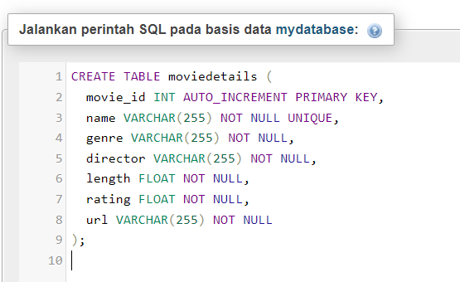MySQL Code

Image 2.2.4.1 mySQL Code Database Table MovieDetails

1. 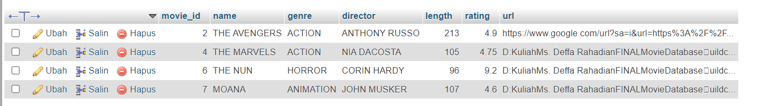MySQL Table

Image 2.2.4.2 Database Connection Table MovieDetails

1. Connection Java Netbeans

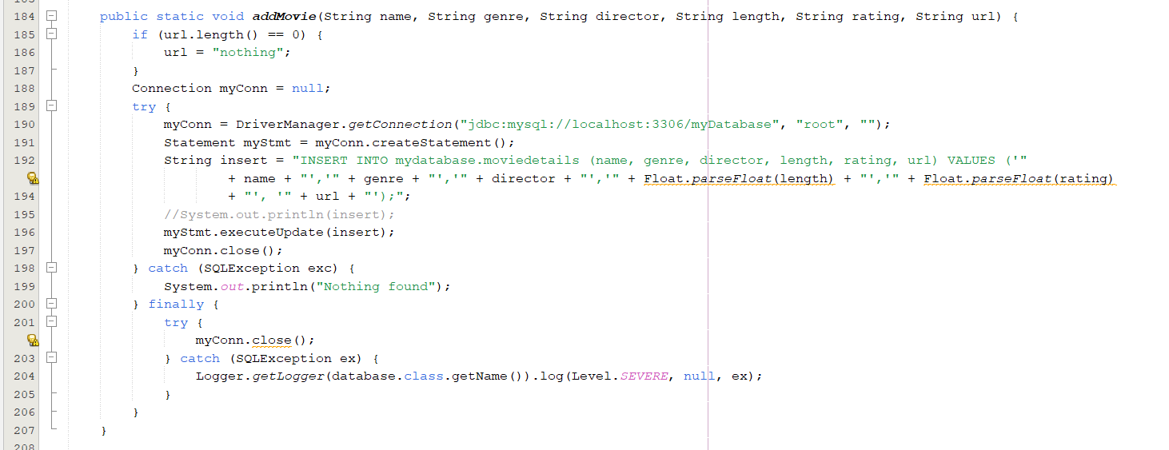

Image 2.2.4.3 Database Connection Add Movie

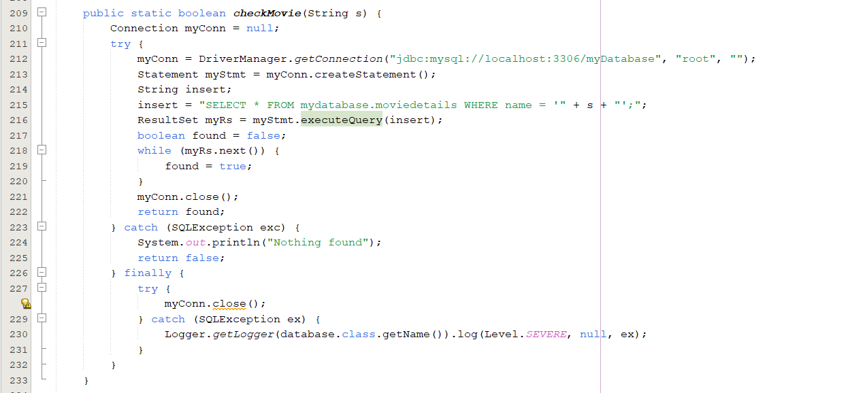

Image 2.2.4.4 Database Connection Check Movie

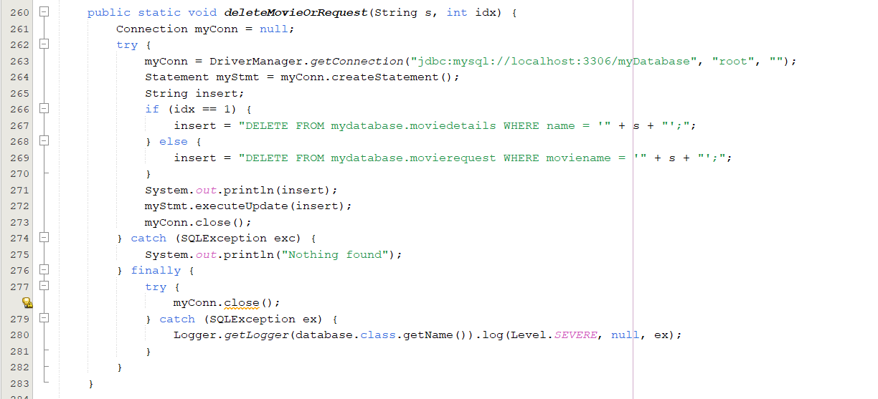

Image 2.2.4.5 Database Connection Delete Movie and Request

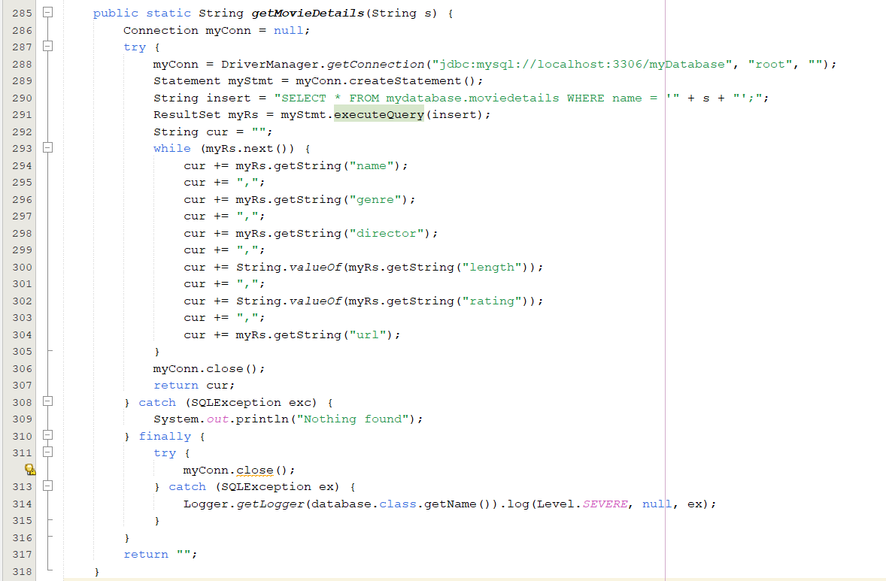

Image 2.2.4.6 Database Connection Get Show Movie

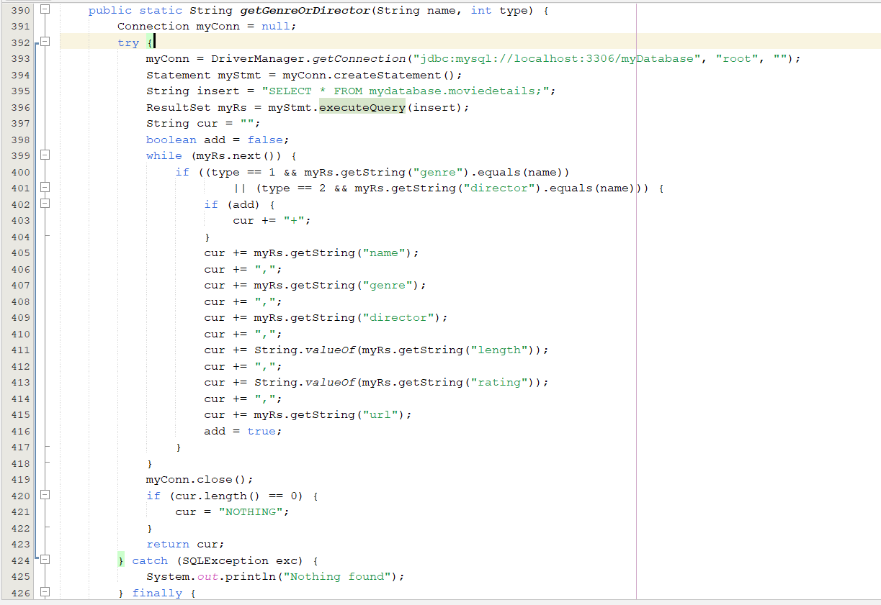

Image 2.2.4.7 Database Connection Get Show Genre or Director

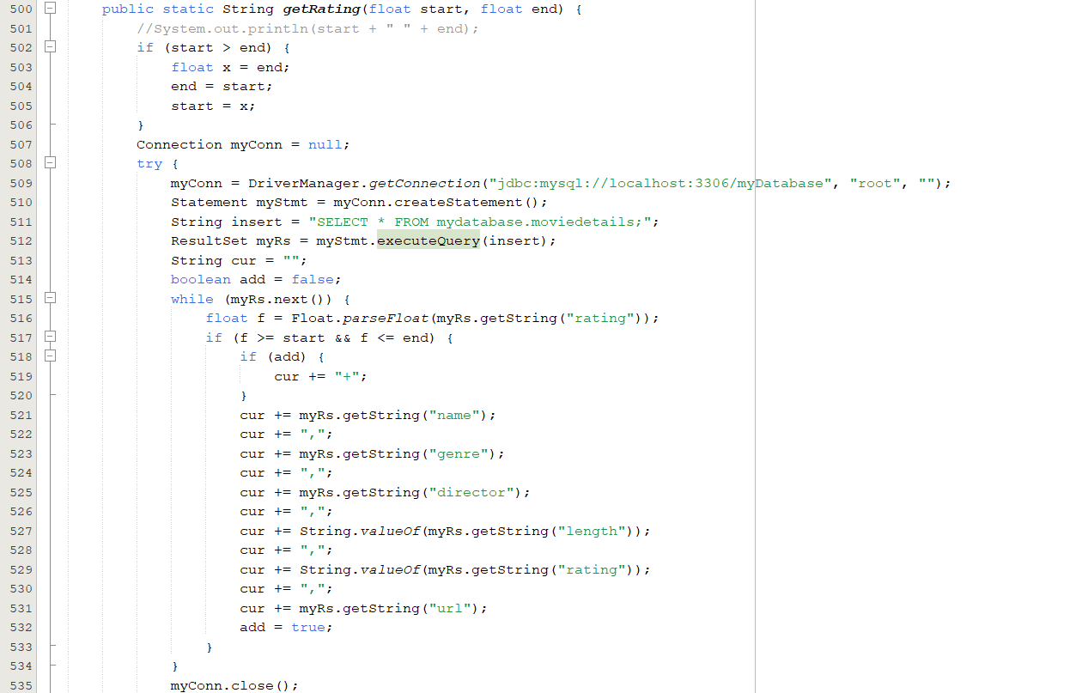

Image 2.2.4.8 Database Connection Get Show Rating

### MovieRequest

1. 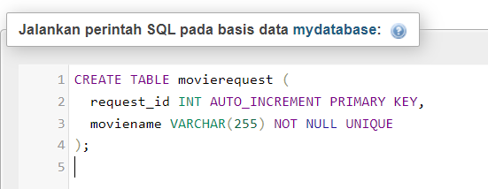MySQL Code

Image 2.2.5.1 mySQL Code Database Table MovieRequest

1. 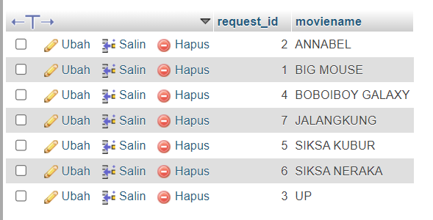MySQL Table

Image 2.2.5.2 Database Table MovieRequest

1. Connection Java Netbeans

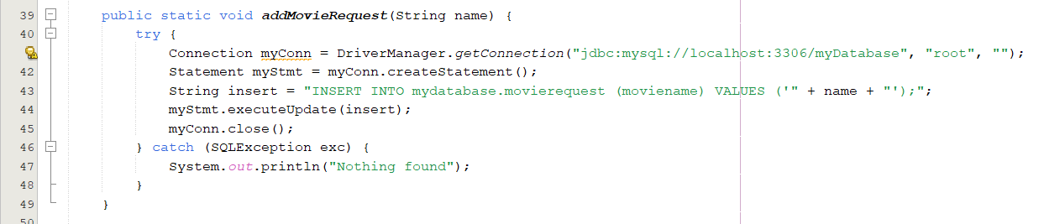

Image 2.2.5.3 Database Connection Add Request Movie

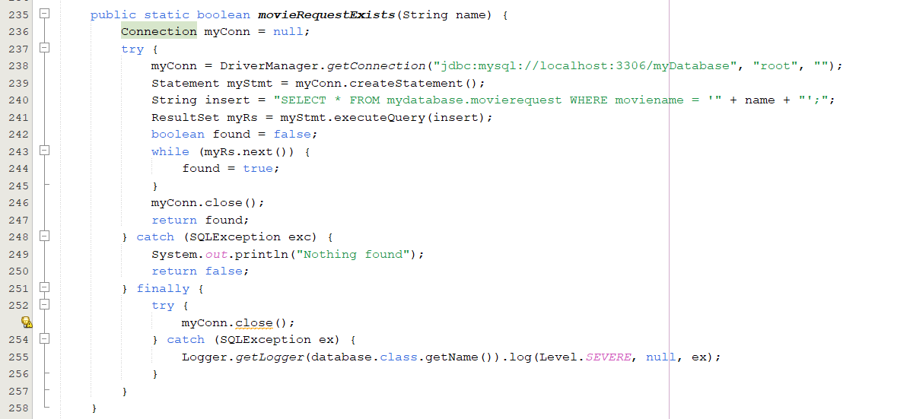

Image 2.2.5.4 Database Connection Movie Request Exist

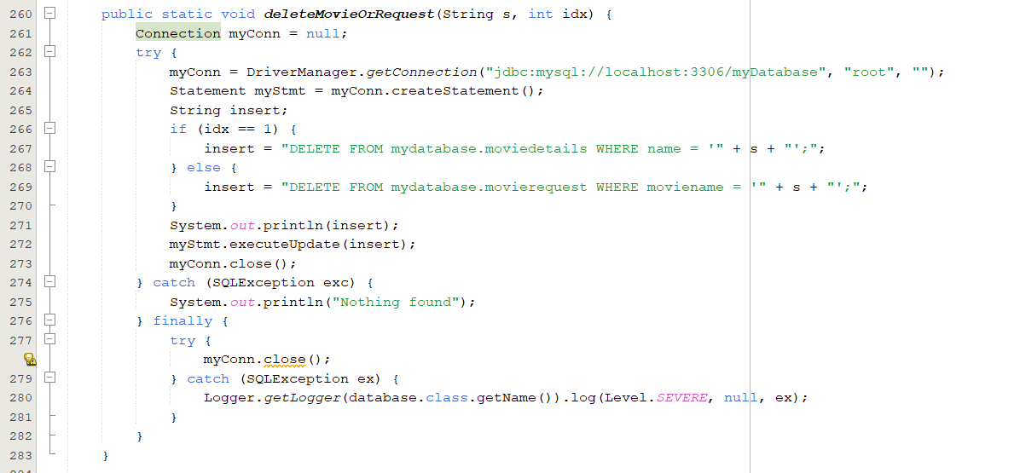

Image 2.2.5.5 Database Connection Delete Movie or Request Movie

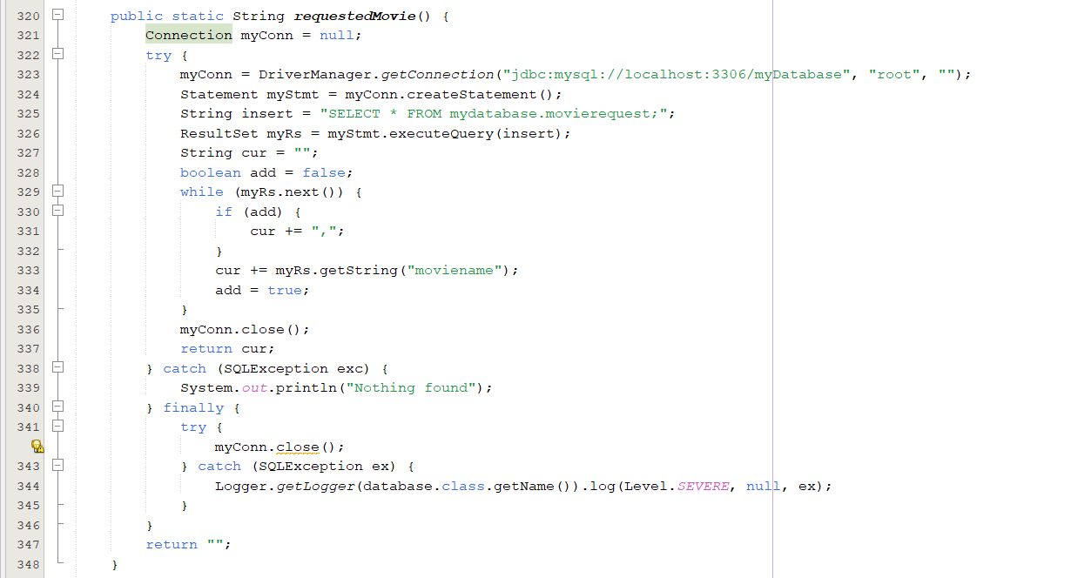

Image 2.2.5.6 Database Connection Get Show Requested Movie

# BAB III OBJECT ORIENTED PROGRAMMING PILLARS

## ENCAPSULATION

Encapsulation promotes data protection by bundling data (attributes) and the methods that operate on that data within a single unit called a class. This concept ensures data integrity and controlled access, safeguarding the application's core functionality.

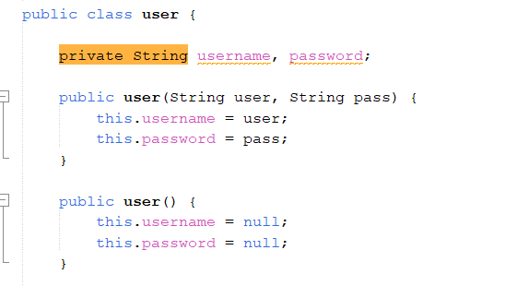

Image 3.1.1 Encapsulation

In the provided code, there is a class named user that demonstrates the concept of encapsulation. The username and password variables are declared as private, which means they can only be accessed within the user class. The toString() method is an example of polymorphism, as it is overridden to provide a specific implementation for the user class.

However, the code does not demonstrate the concepts of inheritance and abstraction.

Inheritance is the mechanism by which classes in Java, Python, and other OOP languages inherits the attribute of other classes. Abstraction means to only show the necessary details to the user and hide the irrelevant information.

In the user class, the username and password variables are encapsulated, meaning they are hidden from other classes and can only be accessed through the methods of the user class. The toString() method is an example of polymorphism, as it is overridden to provide a specific implementation for the user class.

The code does not demonstrate the concept of inheritance, as there is no parent class from which the user class inherits attributes or methods. The code also does not demonstrate the concept of abstraction, as it does not hide irrelevant details from the user.

## INHERITANCE

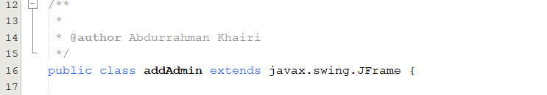Inheritance allows us to create new classes (subclasses) that inherit properties and functionalities from existing classes (superclasses). This promotes code reusability and enables the creation of specialized classes that extend the functionalities of more general classes.































Image 3.2.1 Inheritance

Explanation Inheritance, for example in addAmin :

Inheritance is a fundamental concept in object-oriented programming (OOP) that allows a class to inherit properties and behavior from a parent class. In the provided Java code, the addAdmin class extends the javax.swing.JFrame class, which is an example of inheritance.

The addAdmin class is the child class, and JFrame is the parent class. By extending JFrame, the addAdmin class automatically inherits all the properties and behavior of JFrame, such as the ability to create a window, set its size and title, and handle events. This allows the addAdmin class to focus on its specific functionality, which is to add a new admin user to the system.

The addAdmin class has a constructor that takes no arguments, which calls the initComponents() method to initialize the user interface components and then sets the default close operation for the window using the setDefaultCloseOperation() method.

The setDefaultCloseOperation() method is inherited from JFrame, and it allows the addAdmin class to set the default close operation for the window without having to define its own implementation. This is an example of how the addAdmin class uses inheritance to inherit behavior from JFrame.

By extending JFrame, the addAdmin class automatically inherits many other properties and behavior, such as the ability to set the window size, location, and title, handle events, and more. This reduces the amount of code that needs to be written in the addAdmin class and makes it easier to maintain and extend.

## POLYMORPHISM

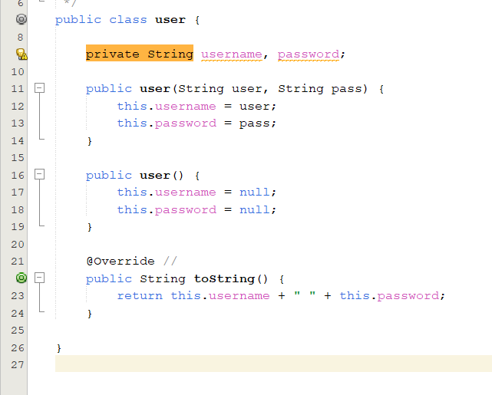Polymorphism refers to the ability of objects to respond differently to the same method call. This flexibility allows for creating generic methods that can handle various object types, enhancing code adaptability and maintainability.

Image 3.3.1 Polymorphism

toString() is a method inherited from the Object class, which is the superclass of all classes in Java. The toString() method is used to convert an object into a string representation.

By default, the toString() method will produce a string representation of the object that includes the class name and memory address. However, in this case, we want to change the string representation of the user object to a concatenation of username and password.

This is done by overriding the toString() method in the user class. The use of the @Override annotation indicates that we are overriding a method from the superclass.

The use of overriding in this case allows us to get a string representation that is more suitable for our needs. Additionally, by overriding the toString() method, we can avoid writing redundant code to print the attributes of the user object.

## ABSTRACTION

Abstraction is one of the fundamental concepts in object-oriented programming (OOP) that allows us to focus on the essential features of an object while ignoring the irrelevant details. In Java, abstraction can be achieved through abstract classes and interfaces.

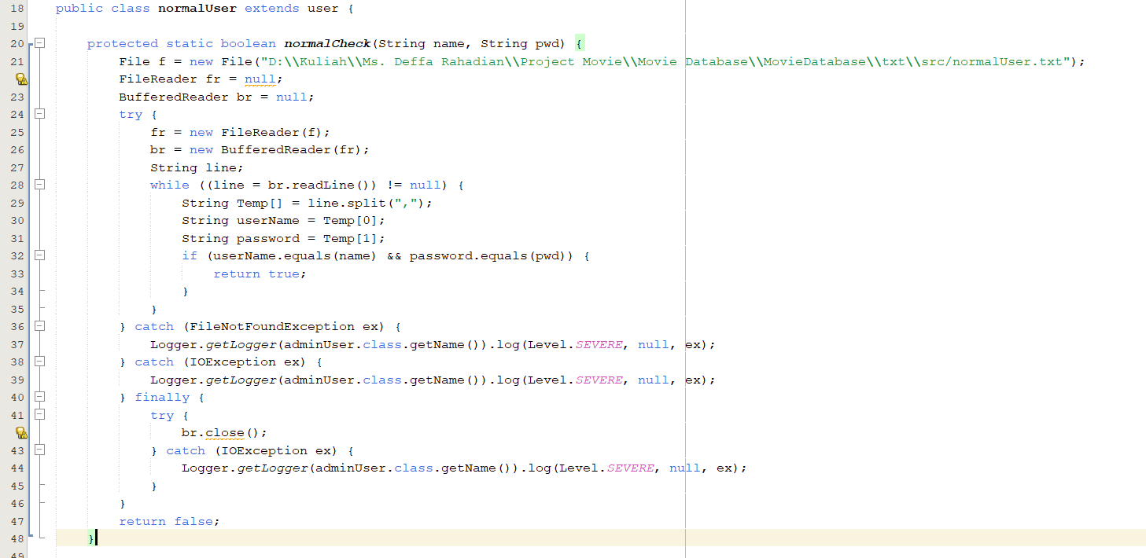An abstract class is a class that cannot be instantiated, but it can be subclassed. An abstract class can contain both abstract and concrete methods. Abstract methods are methods without a body, and they are meant to be overridden by the subclasses.

Image 3.4.1 Abstraction

The Abstraction is present in the normalUser class, which is a subclass of the user class. The normalUser class provides a specific implementation of the user class for normal users, while abstracting away the details of how the user data is stored.

The abstraction is present in the following methods of the normalUser class:

normalCheck() method (lines 14-42): This method takes a username and password as parameters and checks whether a normal user with the given username and password exists in the system. It does this by reading the normalUser.txt file, which contains a list of normal users and their passwords. If a matching user is found, the method returns true; otherwise, it returns false.

# BAB IV SYSTEM DESIGN

## MAIN APPLICATION

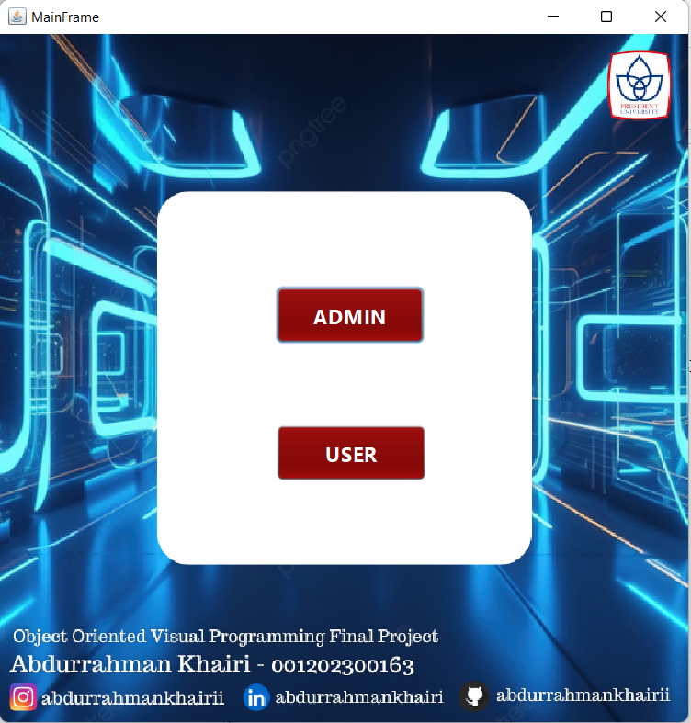

Image 4.1.1 Main Display Application

## ADMIN

### adminLogin

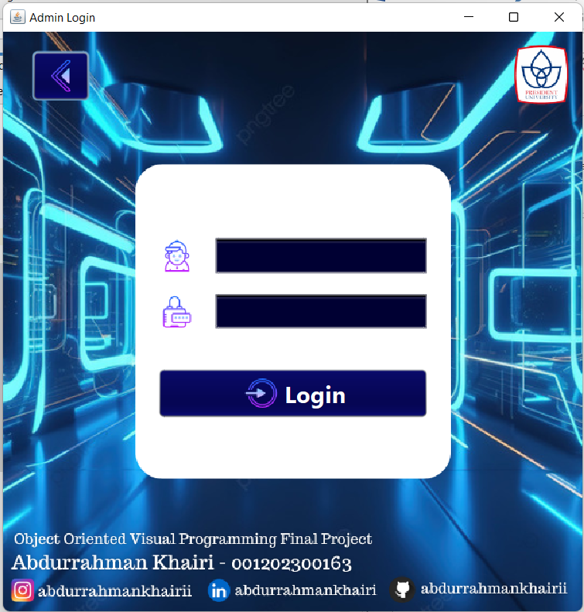

Image 4.2.1.1 Image View Admin Login Form

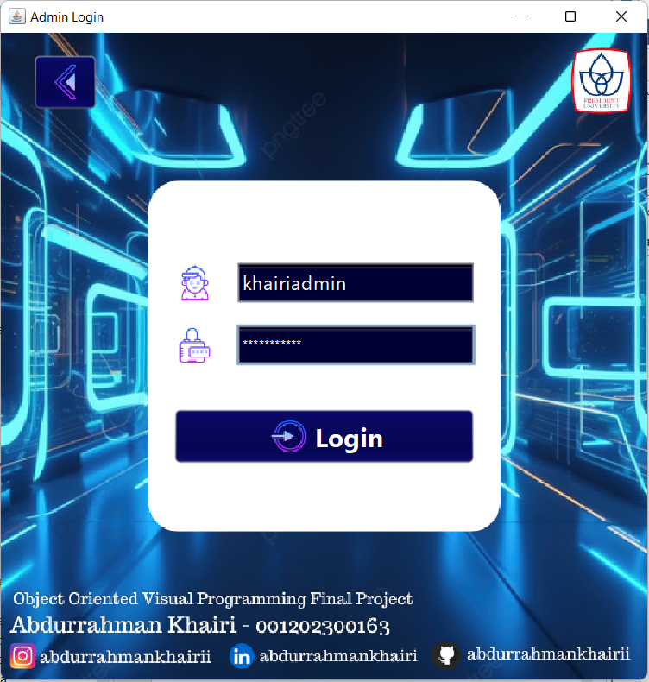

Image 4.2.1.2 Input Admin Form

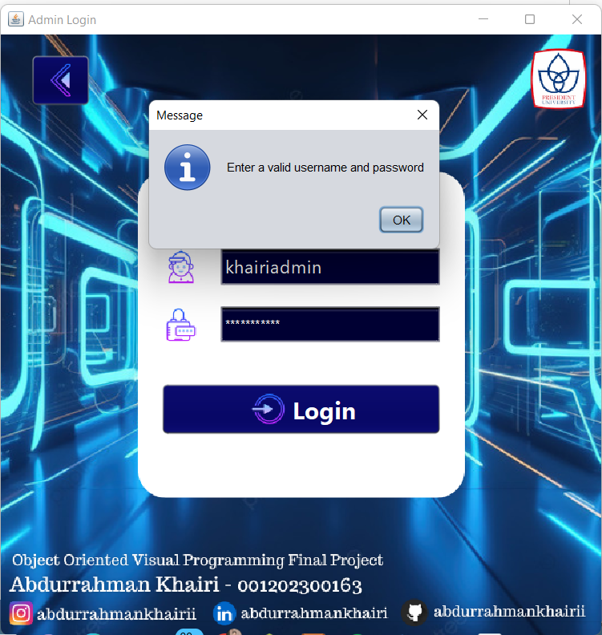

Image 4.2.1.3 Wrong Login Admin Form

### adminForm

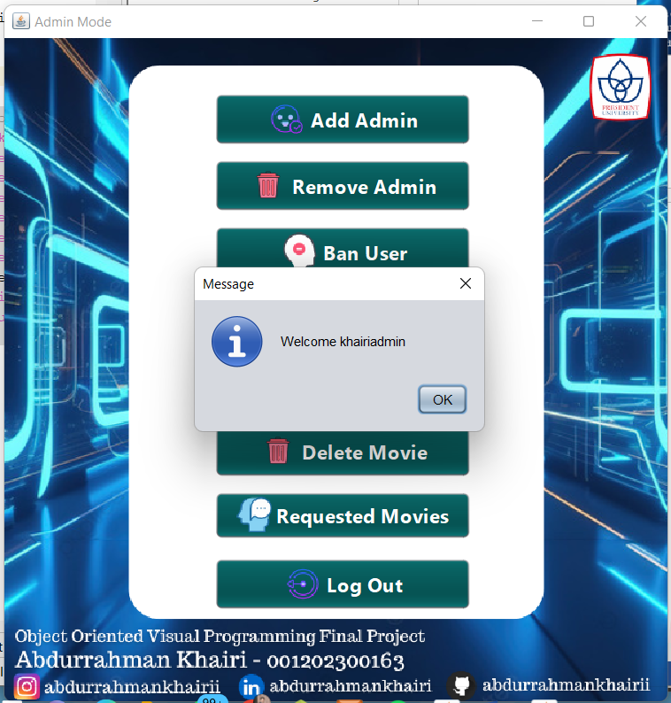

Image 4.2.2.1 Image Login Admin Form

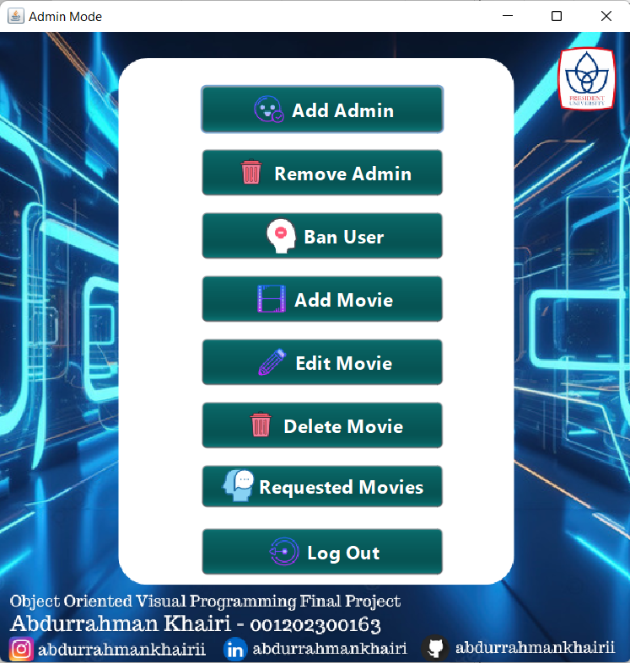

Image 4.2.2.2 View Admin Form

### addAdmin

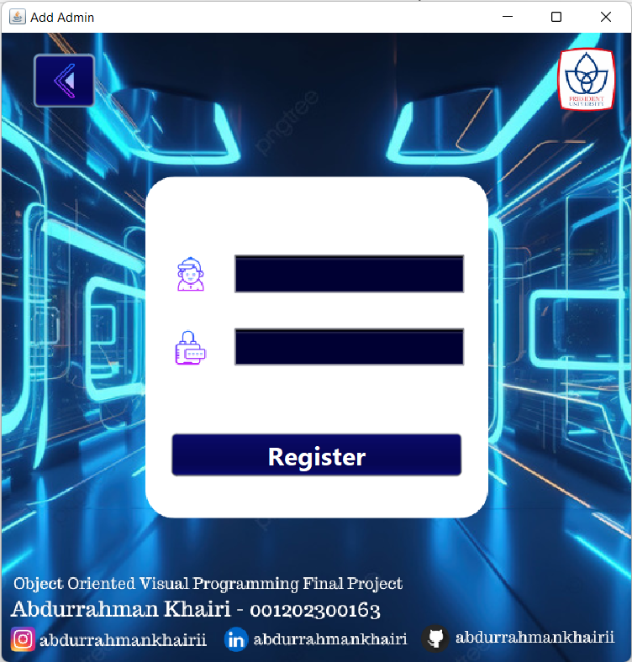

Image 4.2.3.1 Form Add Admin

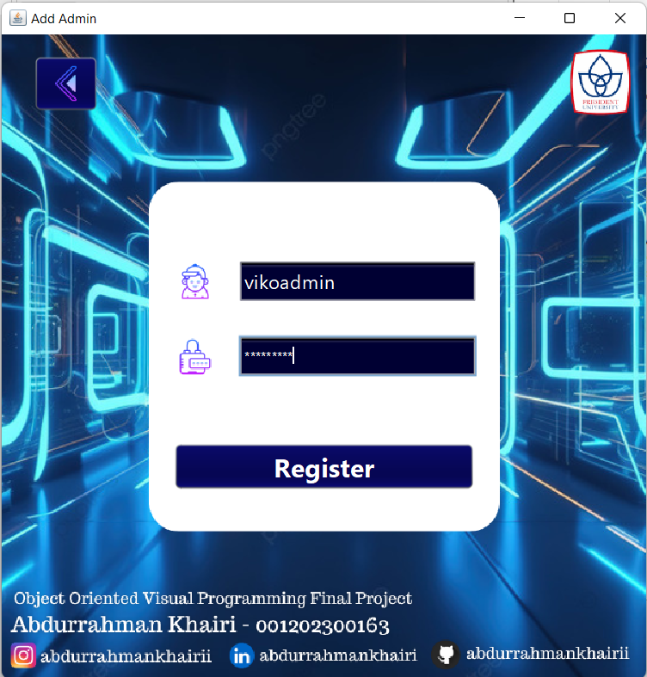

Image 4.2.3.2 Input Add Admin Form

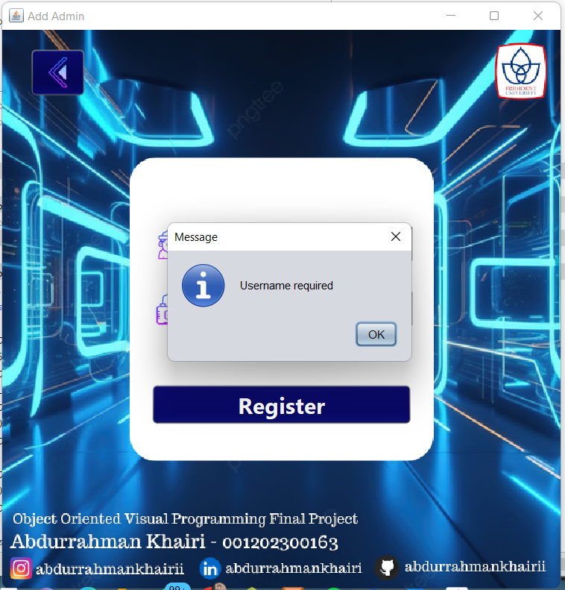

Image 4.2.3.3 Username and Password Required

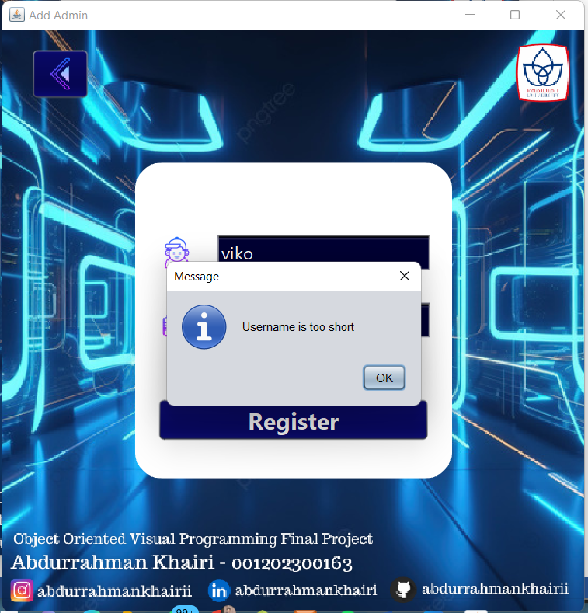

Image 4.2.3.4 Username and Password Too Short

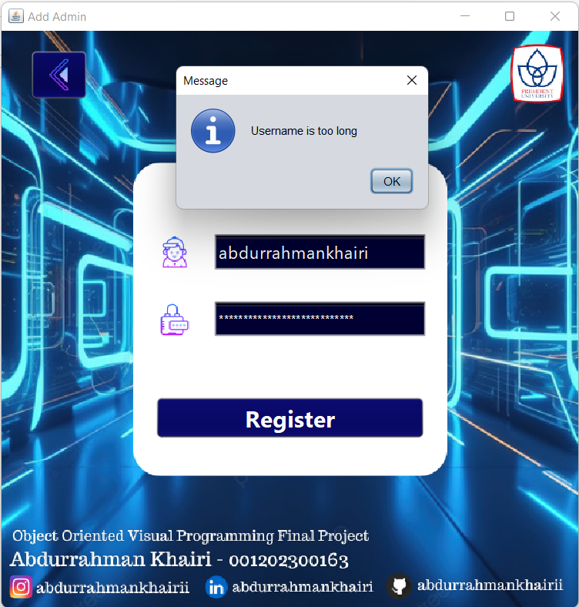

Image 4.2.3.5 Username and Password Too Long

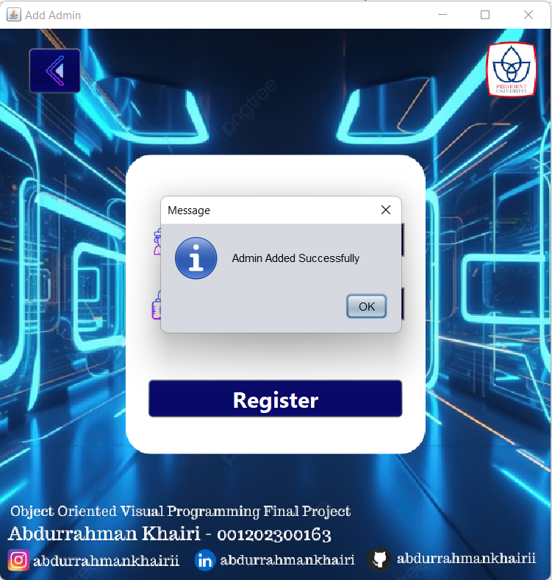

Image 4.2.3.6 Admin Added Successfully

### RemoveAdmin

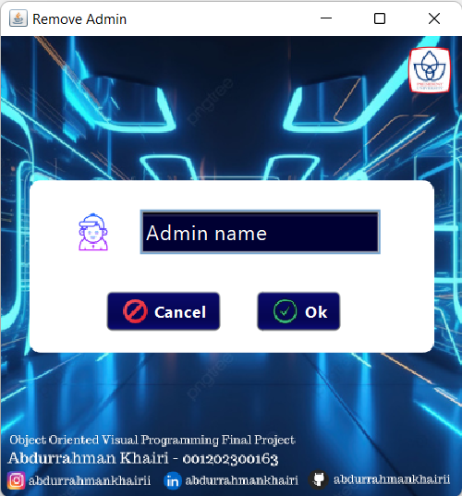

Image 4.2.4.1 View Remove Admin Form

Image 4.2.3. 7 View Remove Admin Form

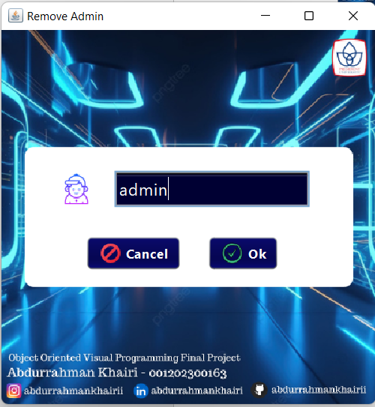

Image 4.2.4.2 Input Remove Admin Form

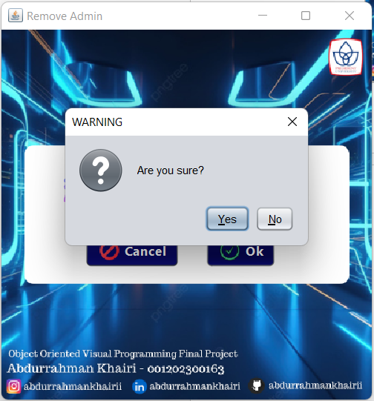

Image 4.2.4.3 Cancel Remove Admin

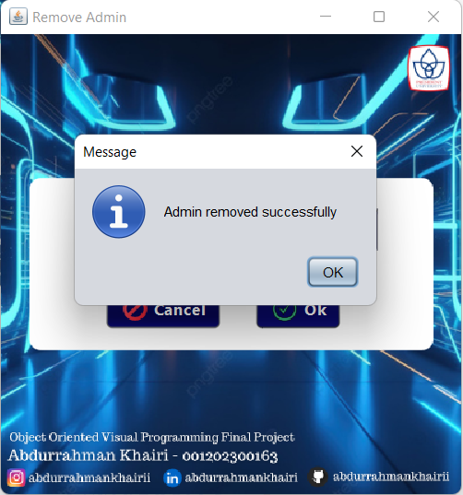

Image 4.2.4.4 Admin Removed Successfully

### BanUser

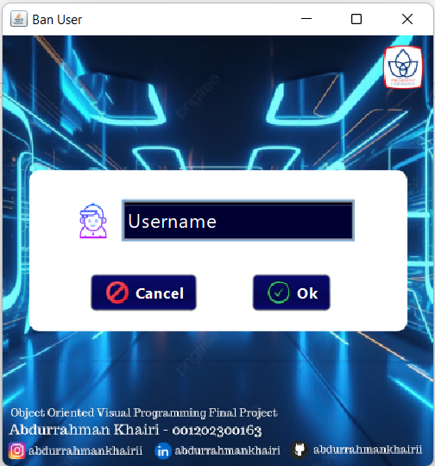

Image 4.2.5.2 View Ban User Form

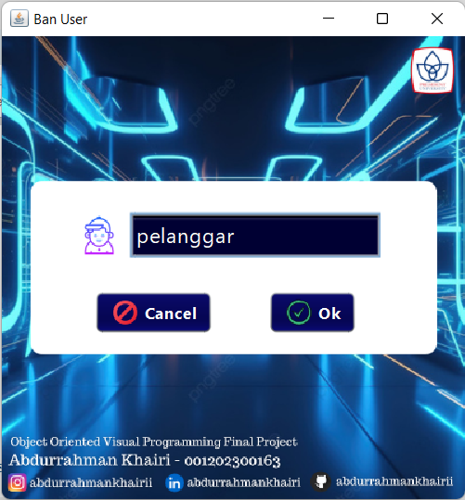

Image 4.2.5.3 Input Ban User Form

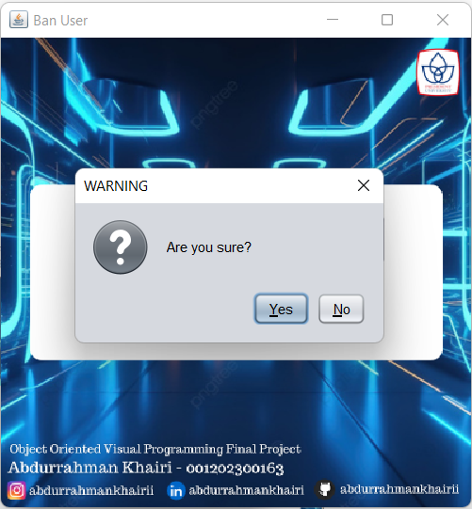

Image 4.2.5.4 Cancel Ban User Form

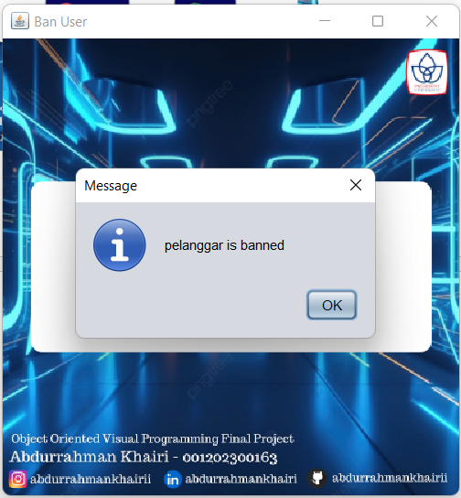

Image 4.2.5.5 Banned User

### addMovie

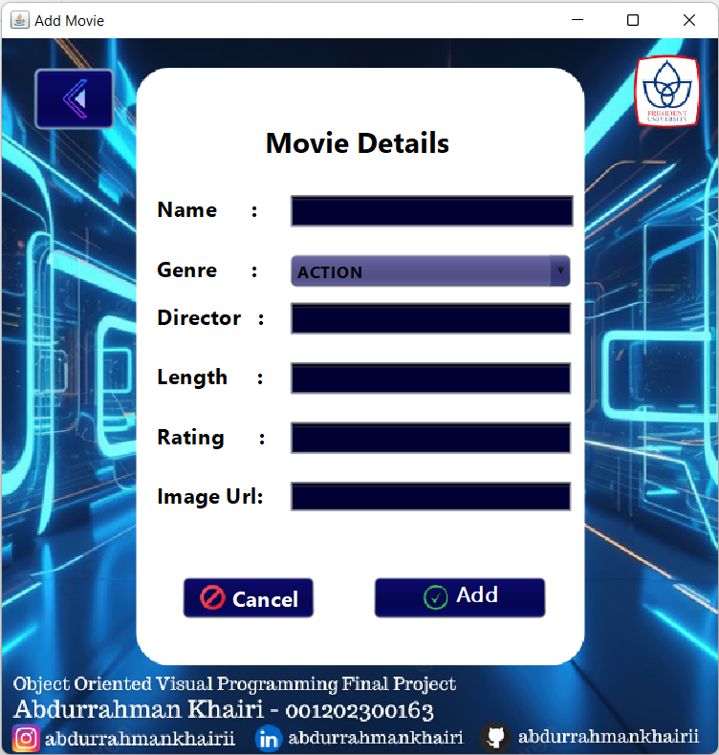

Image 4.2.6.1 View Add Movie Form

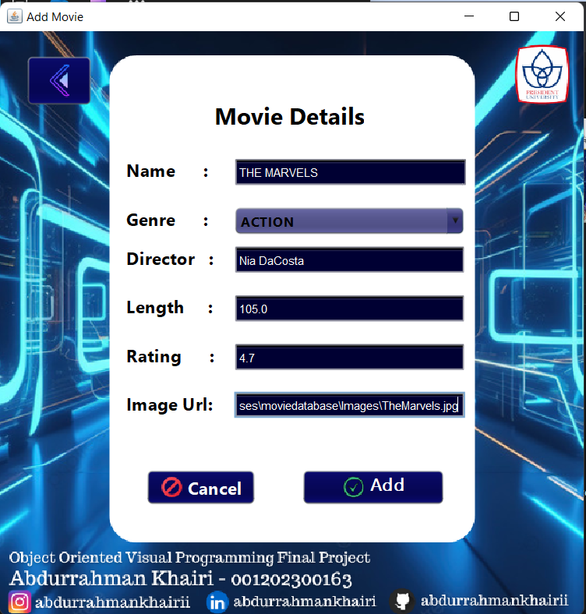

Image 4.2.6.2 Input Add Movie Form

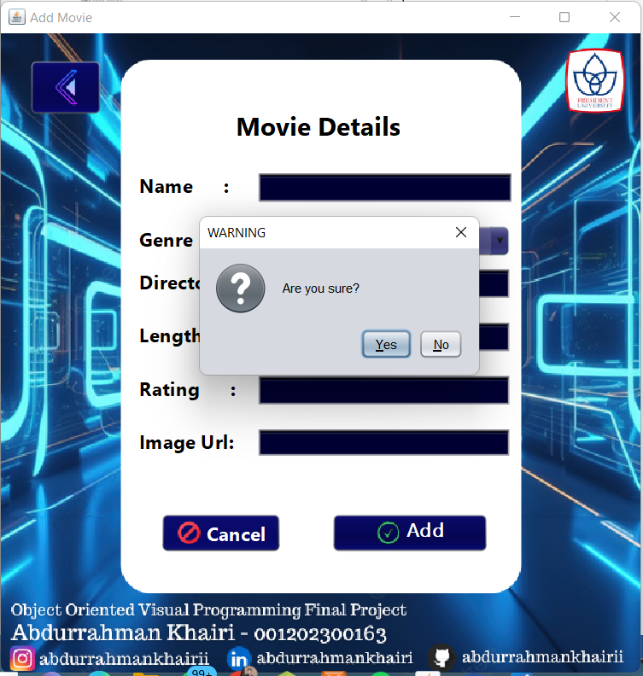

Image 4.2.6.3 Cancel Add View Form

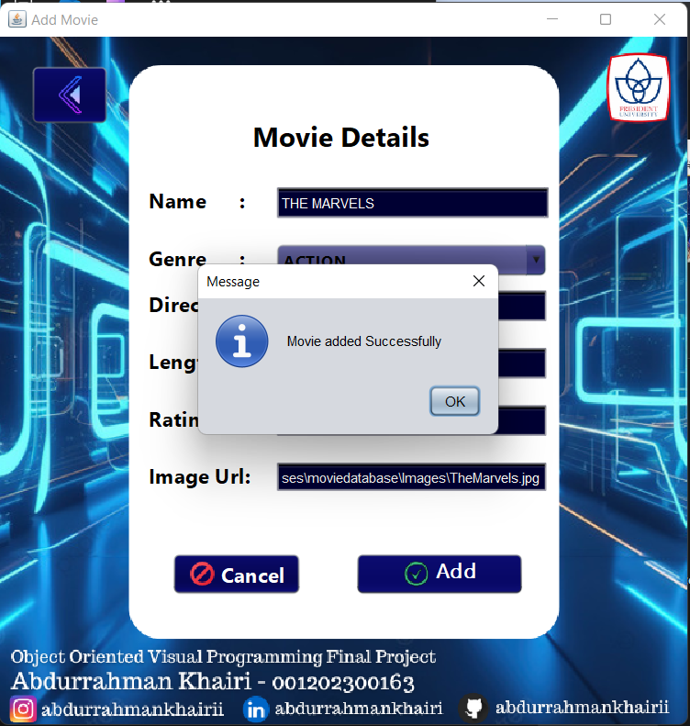

Image 4.2.6.4 Movie Added Successfully

### editMovie

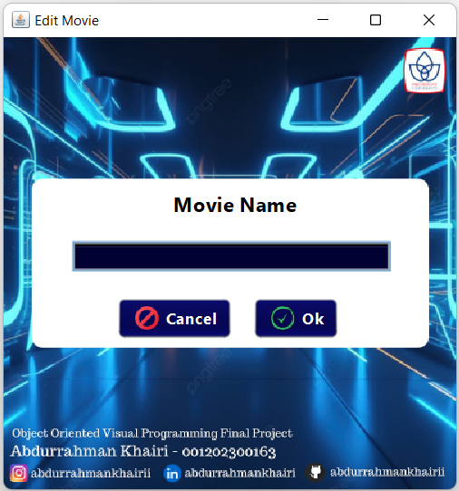

Image 4.2.7.1 View Edit Movie Form

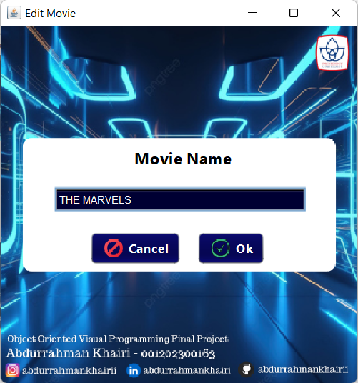

Image 4.2.7.2 Input Edit Movie Form

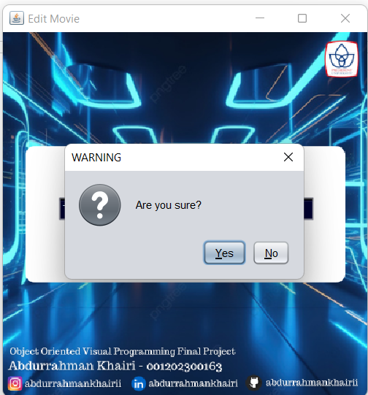

Image 4.2.7.3 Cancel Edit Movie Form

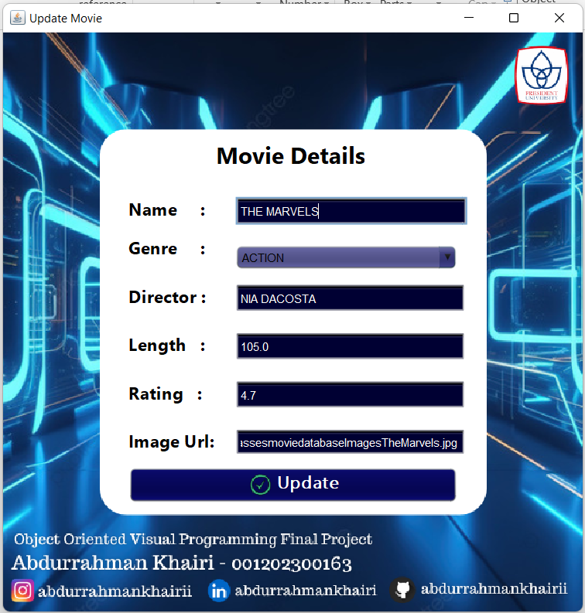

Image 4.2.7.4 View Update Movie Form

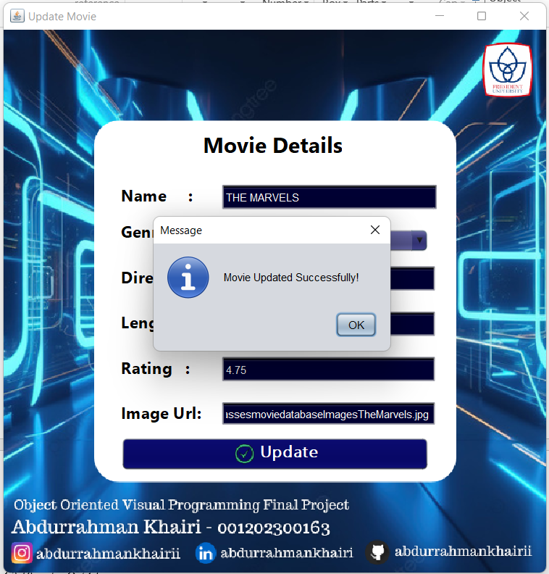

Image 4.2.7.5 Movie Updated Successfully

### deleteMovie

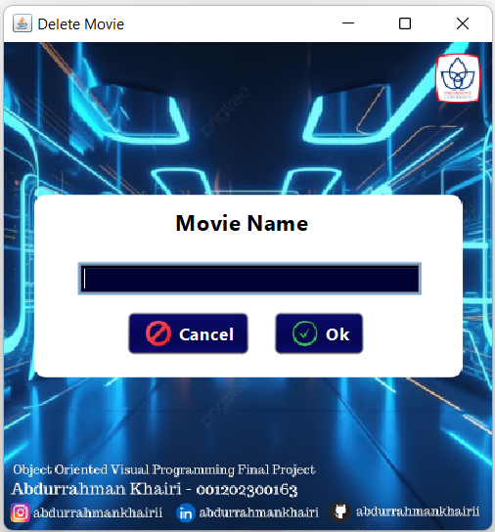

Image 4.2.8.1 View Delete Movie Form

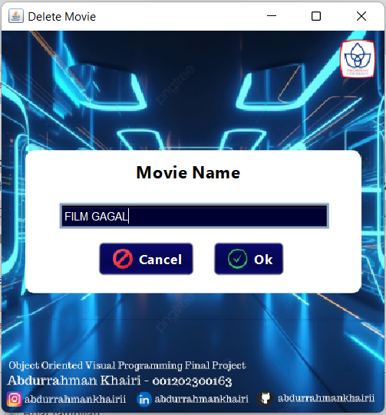

Image 4.2.8.2 Input Delete Movie Form

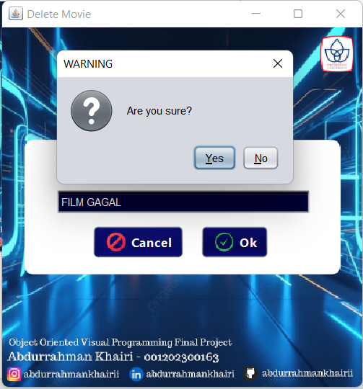

Image 4.2.8.3 Cancel Delete Movie Form

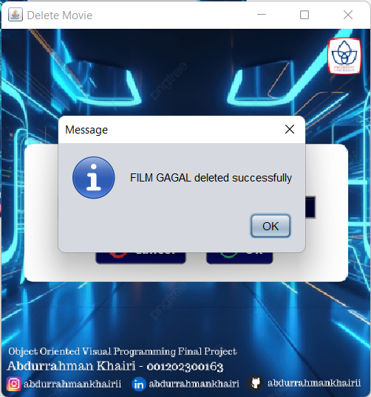

Image 4.2.8.4 Movie Deleted Successfully

### requestedMovie

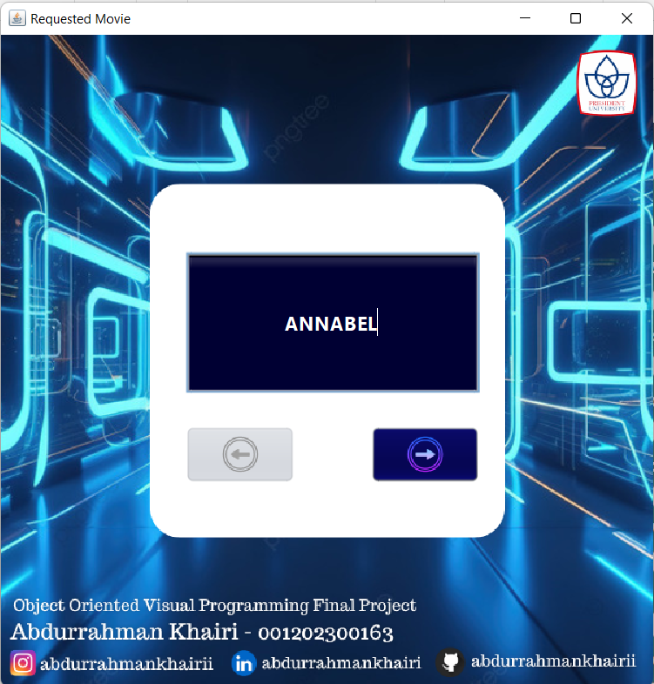

Image 4.2.9.1 View First Requested Movie

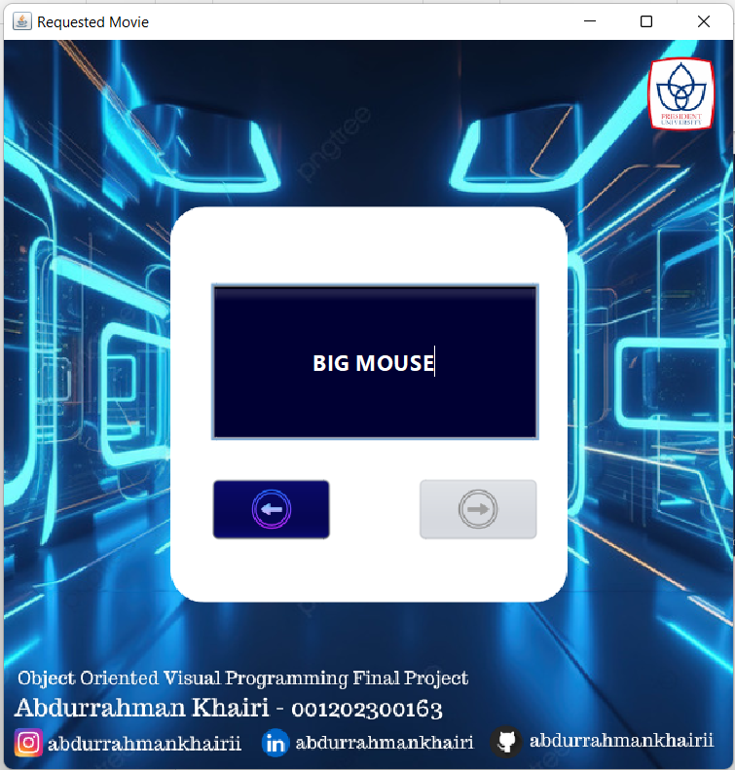

Image 4.2.9.2 View Last Request Movie

### logOutAdmin

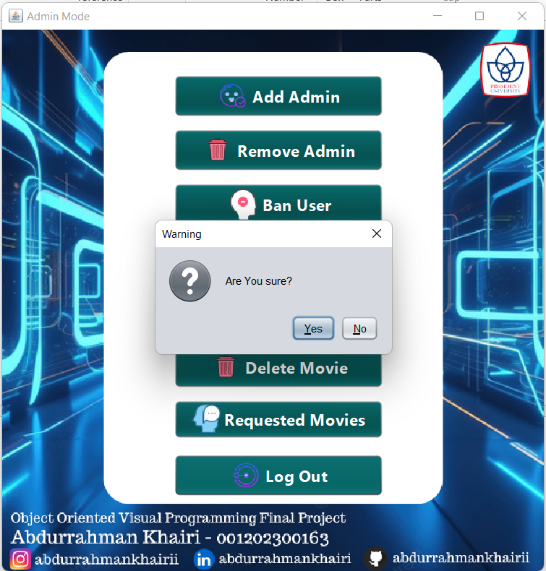

Image 4.2.10.1 LogOut Admin

## USER

### UserLogin

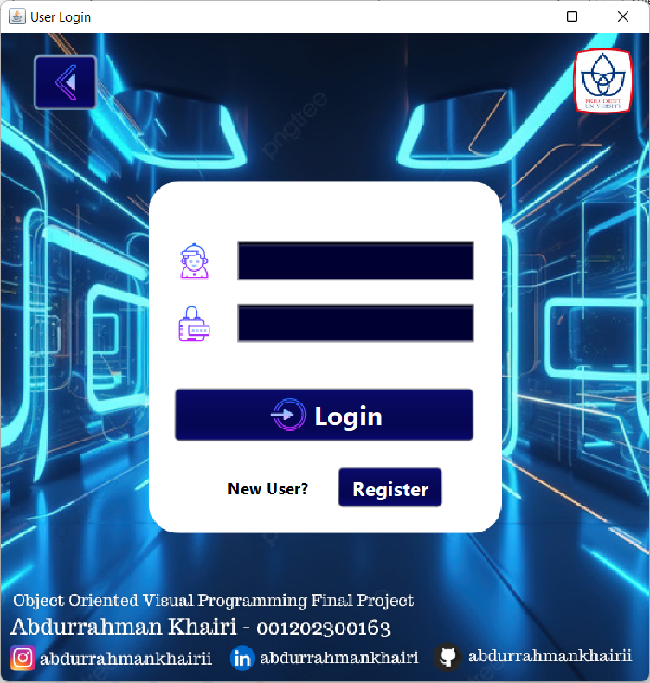

Image 4.3.1.1 View LogIn User Form

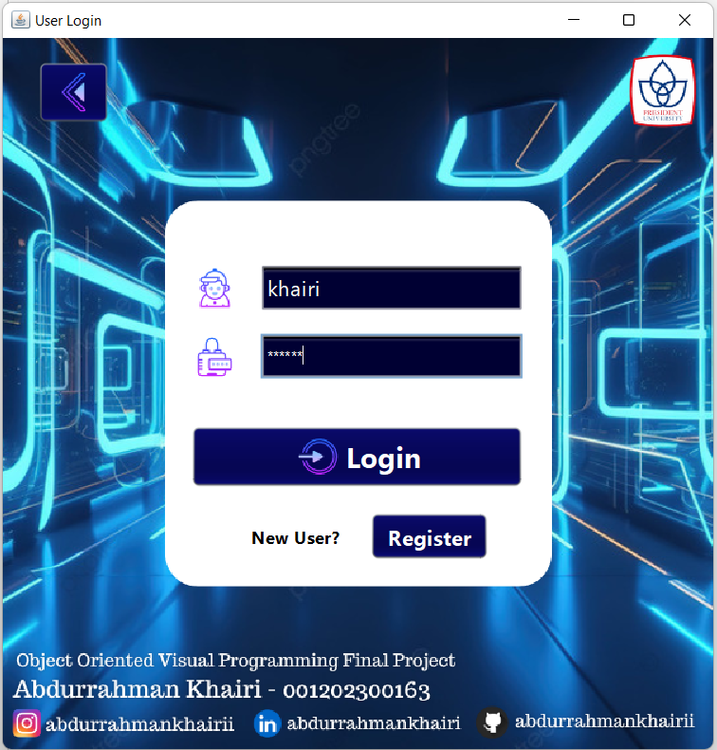

Image 4.3.1.2 Input Login User Form

### RegisterUser

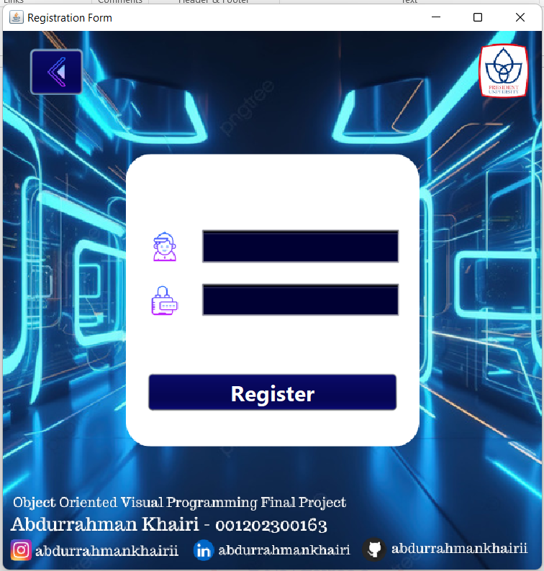

Image 4.3.2.1 View Regiestration User Form

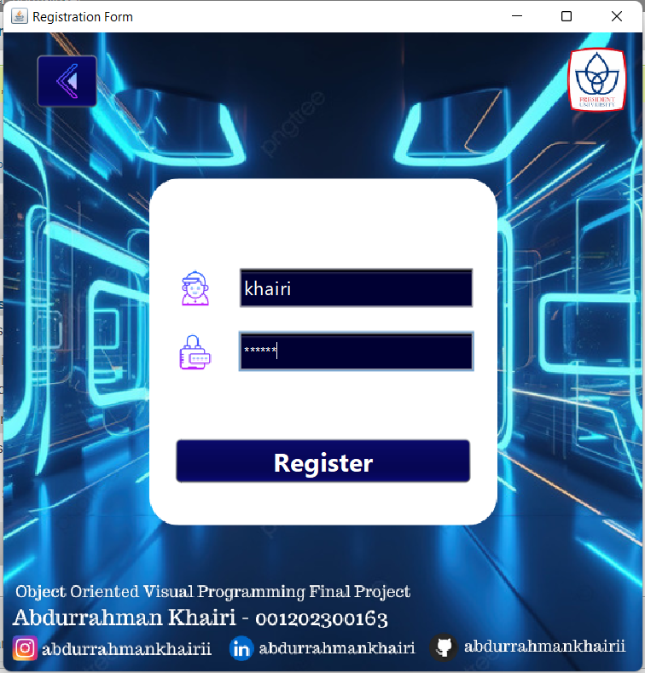

Image 4.3.2.2 Input Registration User Form

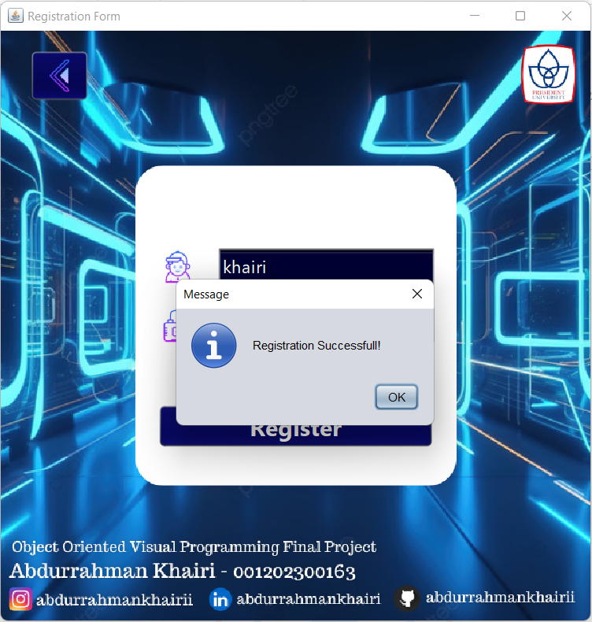

Image 4.3.2.3 Registration User Successfully

### UserForm

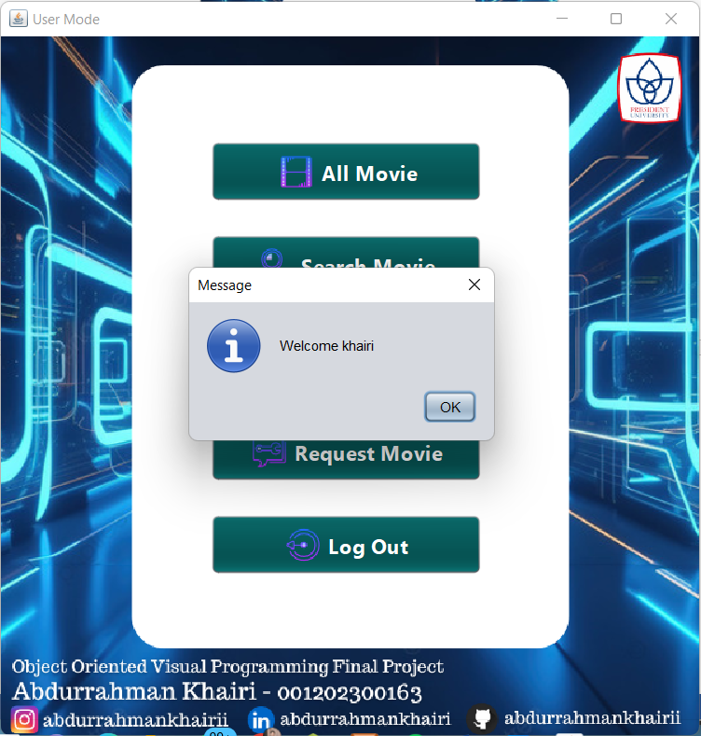

Image 4.3.3.1 LogIn User Form

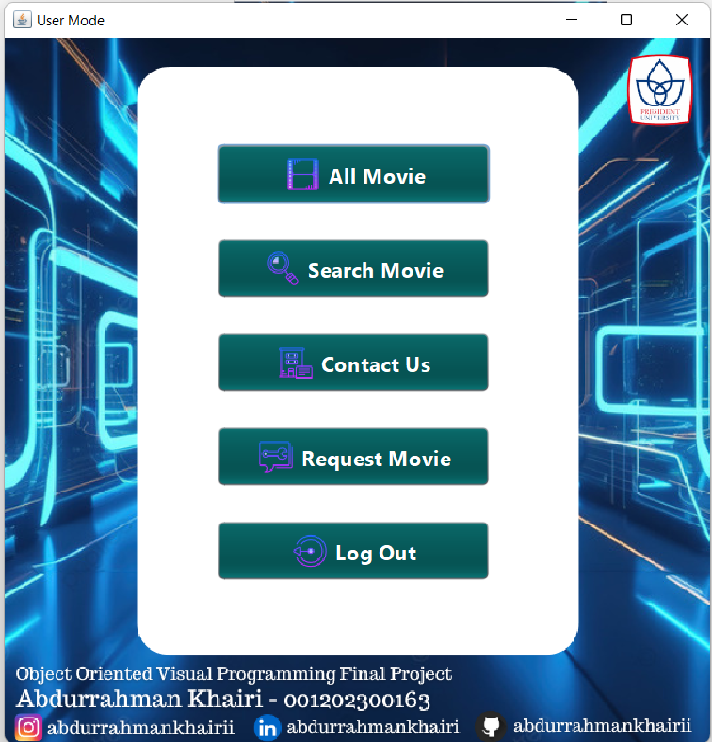

Image 4.3.3.2 View User Form

### AllMovie

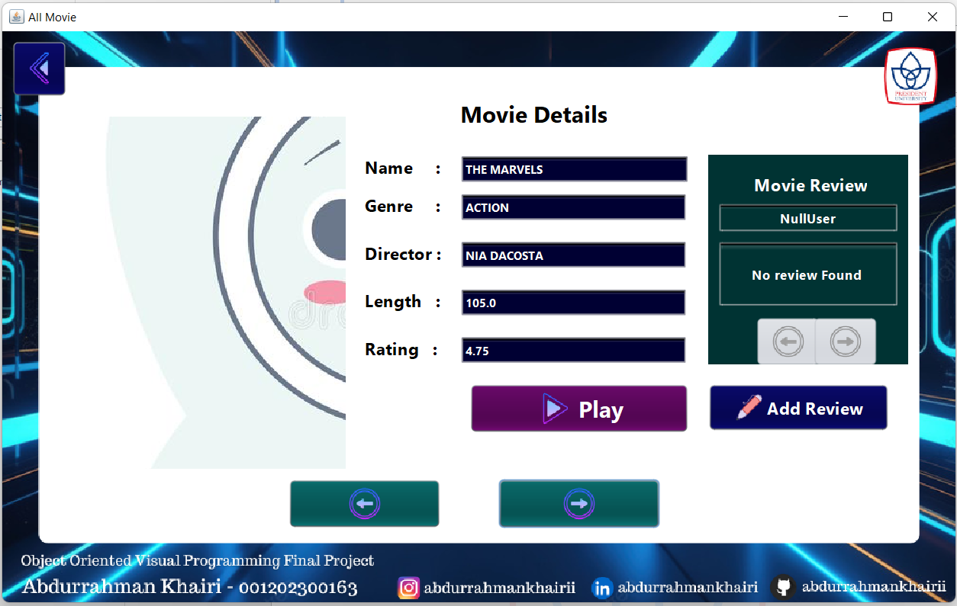

Image 4.3.4.1 View Display All Movie Details

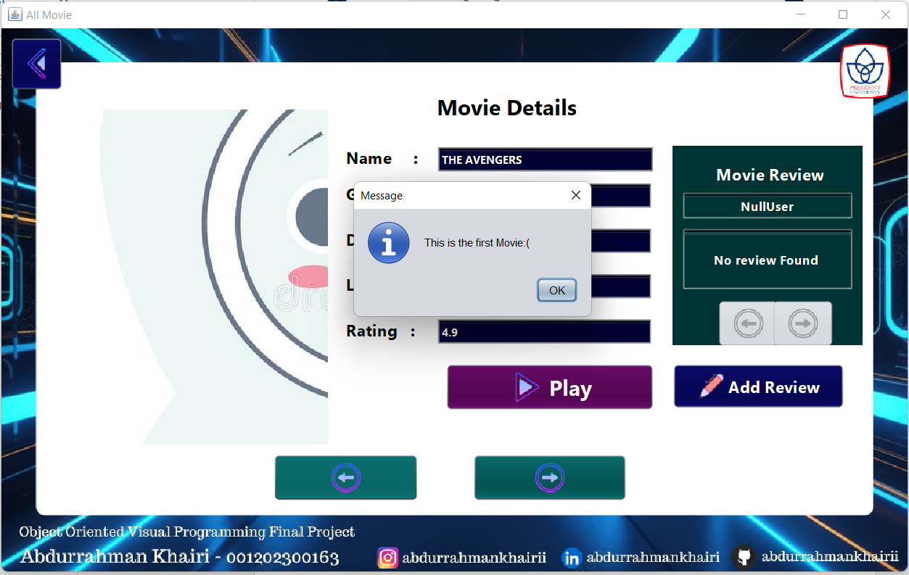

Image 4.3.4.2 View First Movie Details

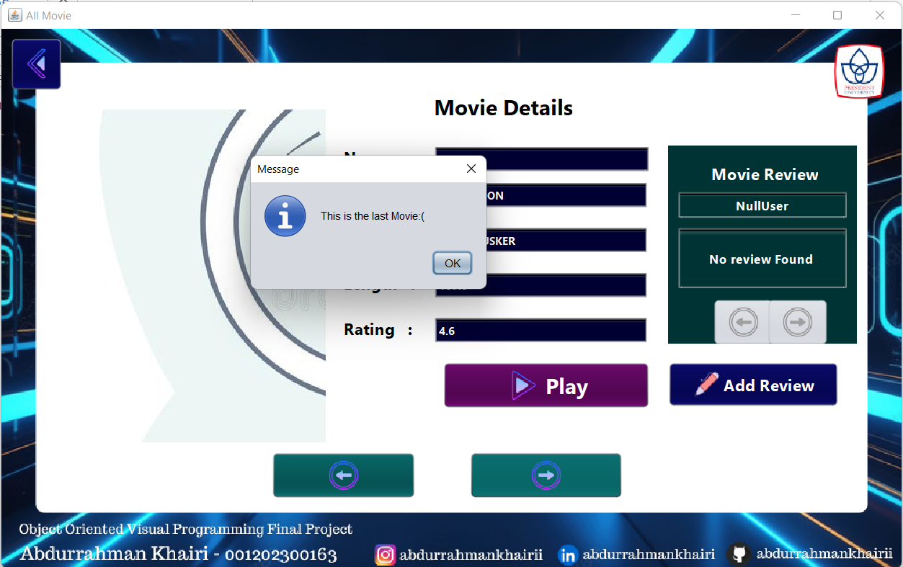

Image 4.3.4.3 View Last Movie Details

### AddReview

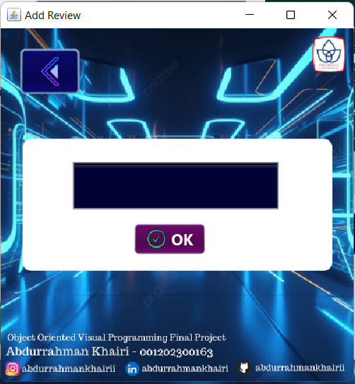

Image 4.3.5.1 View Add Review Form

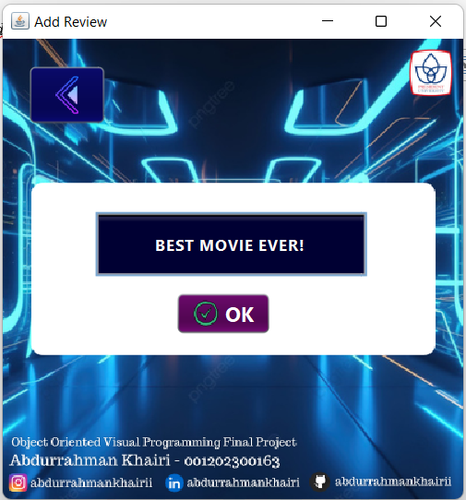

Image 4.3.5.2 Input Add Review Form

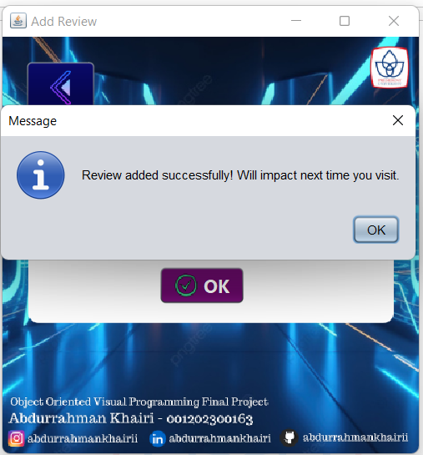

Image 4.3.5.3 Review Added Successfully

### SearchMovie

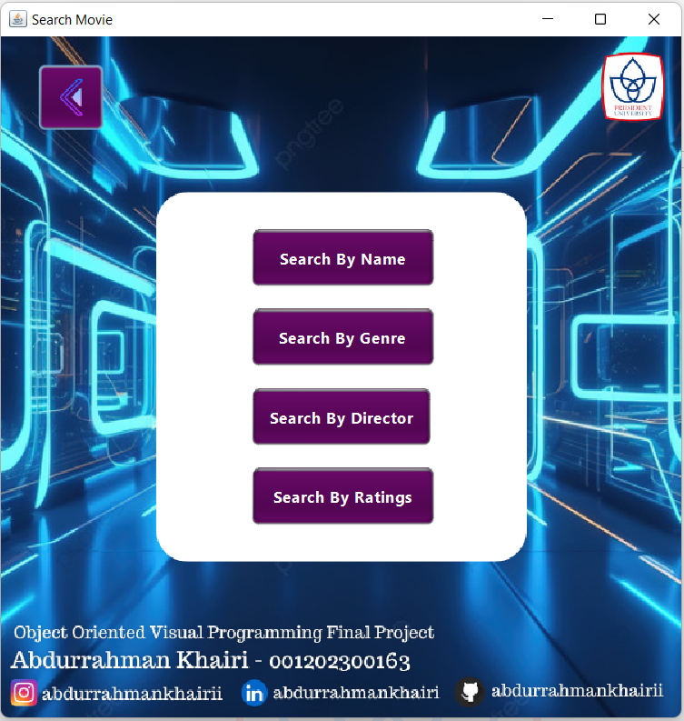

Image 4.3.6.1 View Search Movie Form

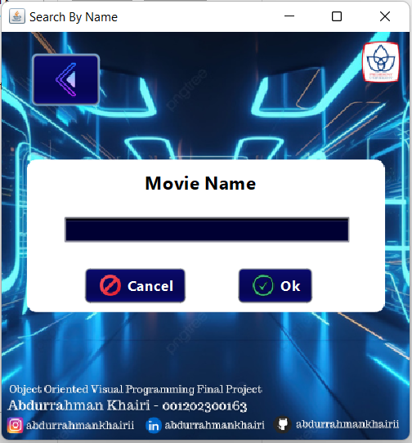

Image 4.3.6.2 View Serch Movie By Name Form

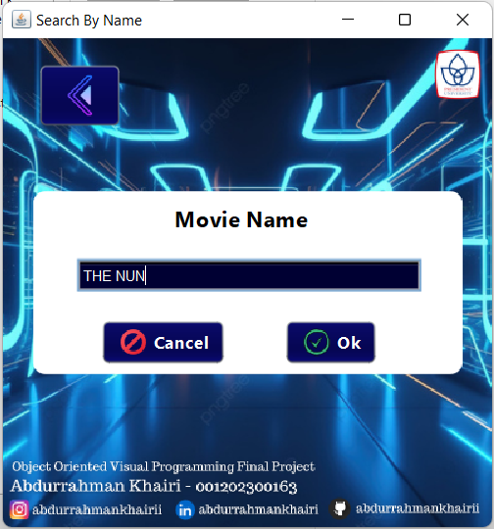

Image 4.3.6.3 Input Serach Movie By Name Form

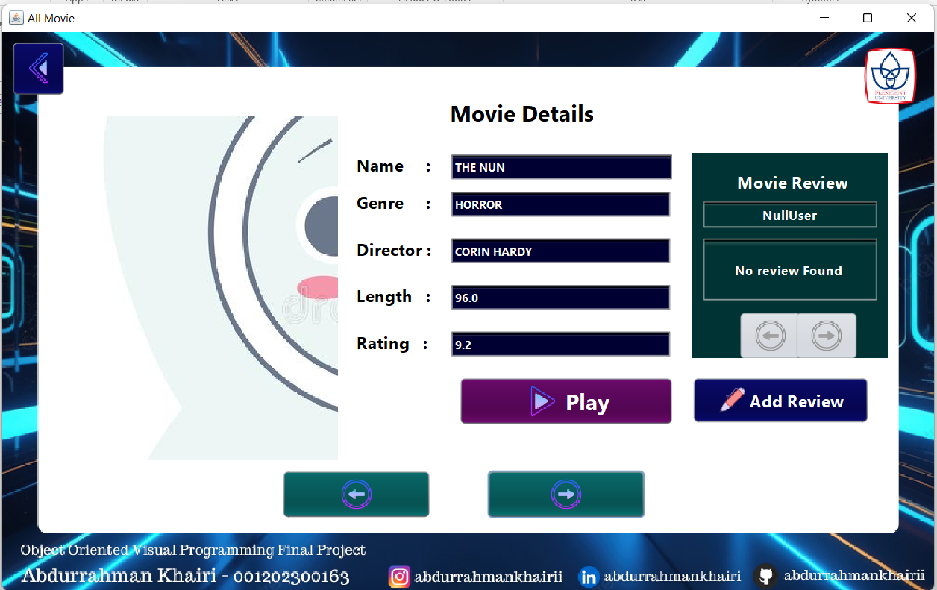

Image 4.3.6.4 Display Movie Details By Searching Name Form

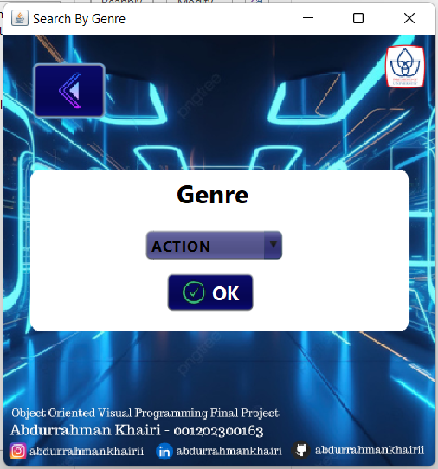

Image 4.3.6.5 View Search Movie By Genre Form

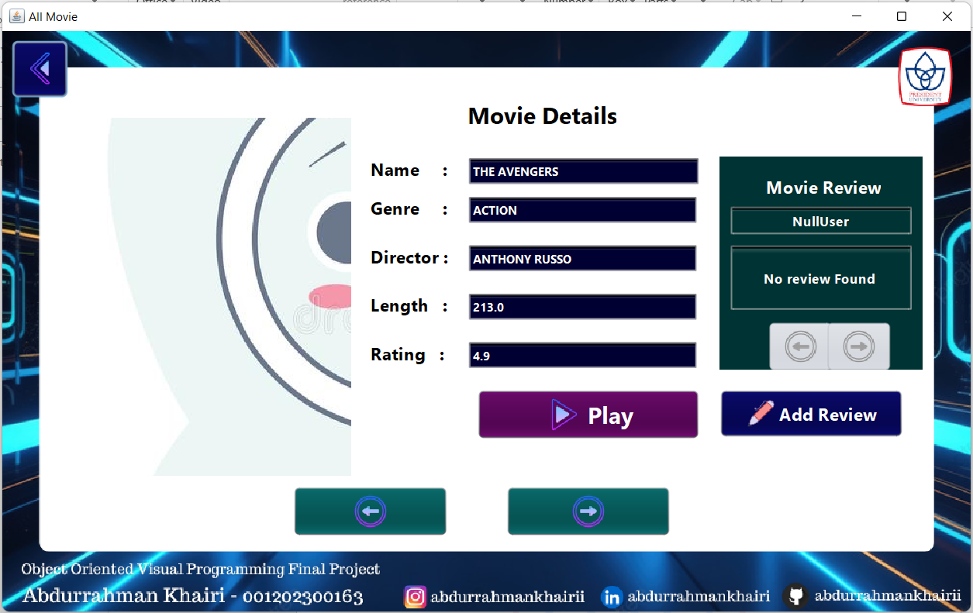

Image 4.3.6.6 Display Movie Details By Seaching Genre Form

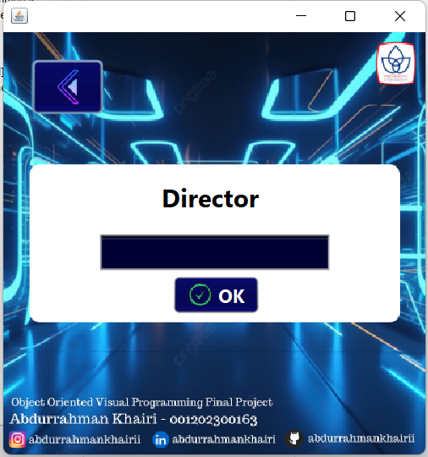

Image 4.3.6.7 View Search Movie By Director Form

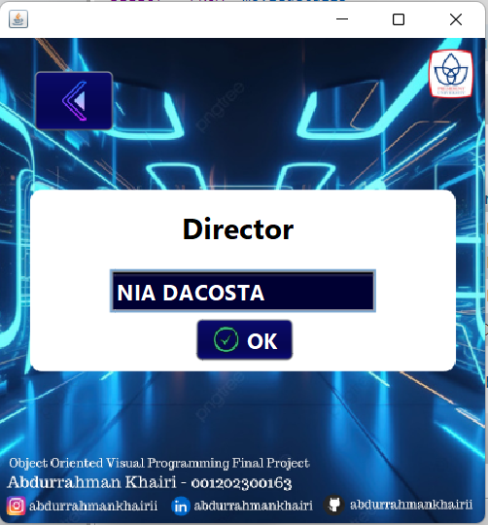

Image 4.3.6.8 Input Search Movie By Director Form

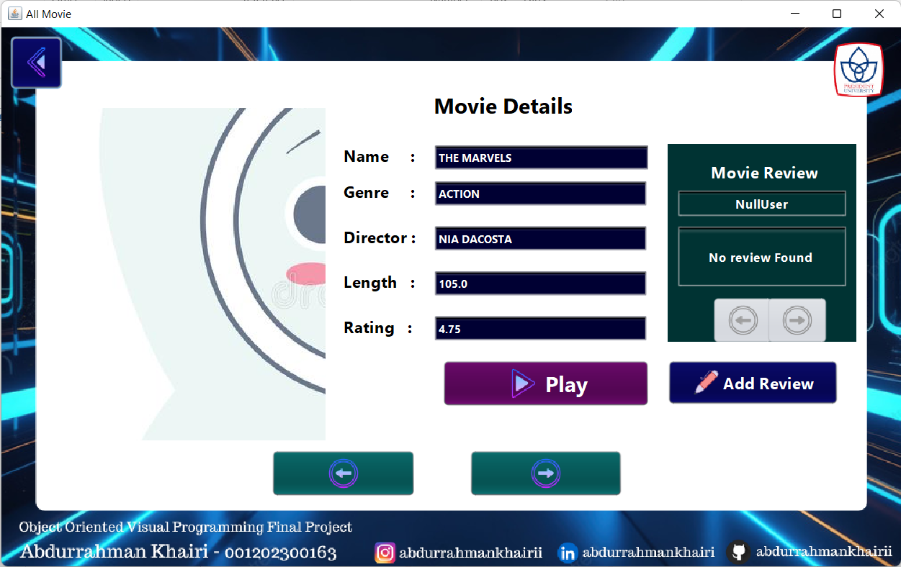

Image 4.3.6.9 Display Movie Details By Searching Director Form

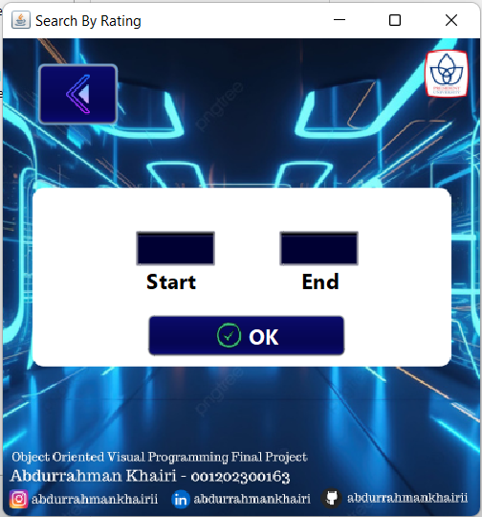

Image 4.3.6.10 View Search Movie By Rating Form

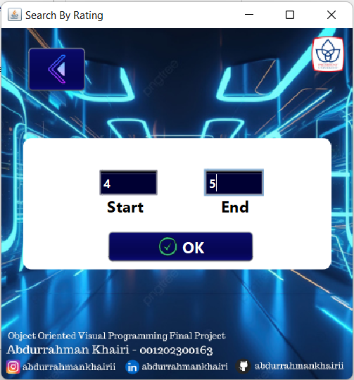

Image 4.3.6.11 Input Search Movie By Rating Form

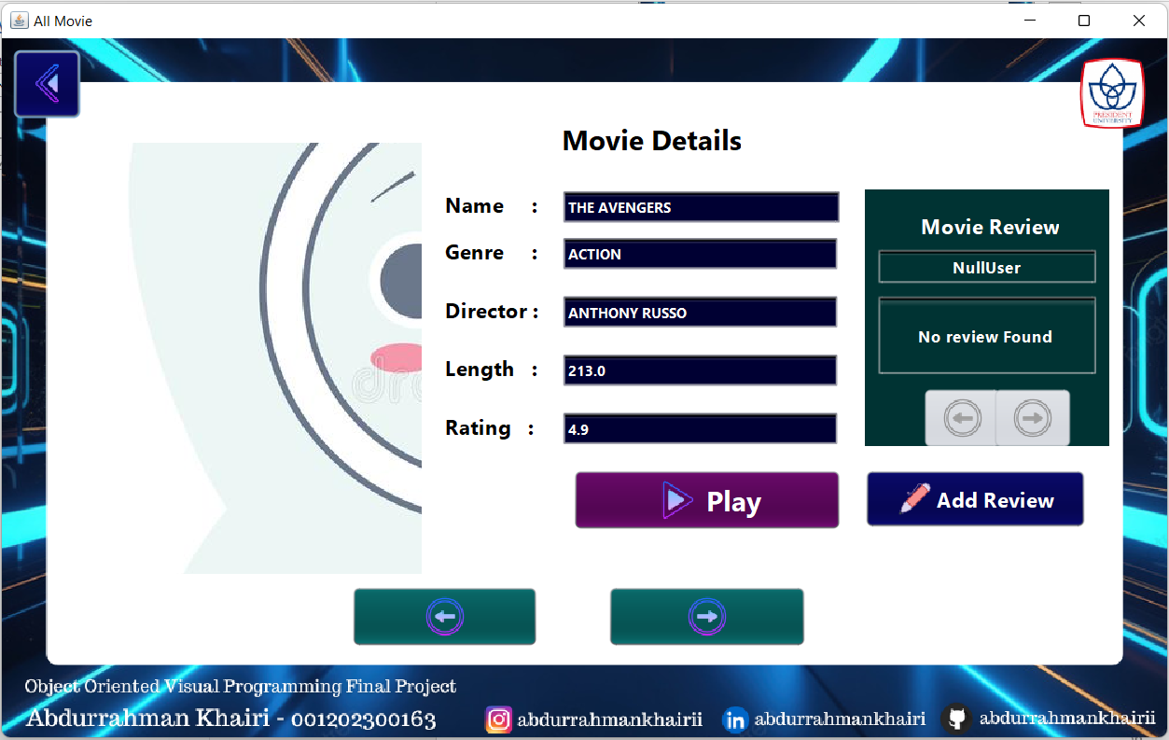

Image 4.3.6.12 Display Movie Details By Searching Rating Form

### ContactUs

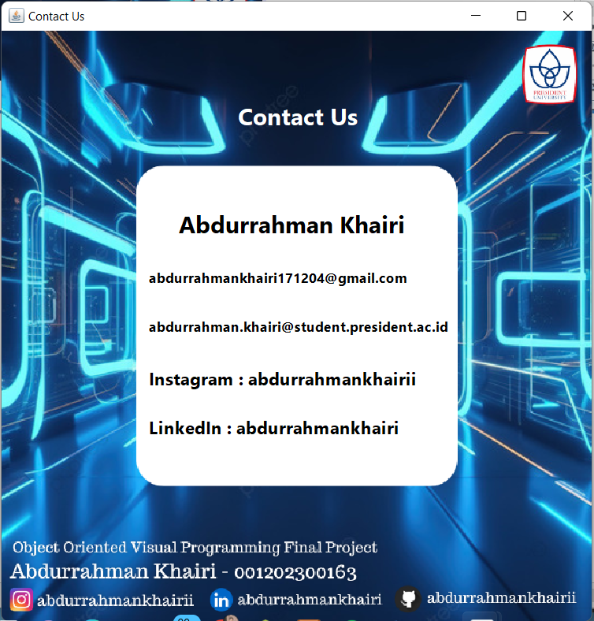

Image 4.3.7.1 View Contact Us

### RequestMovie

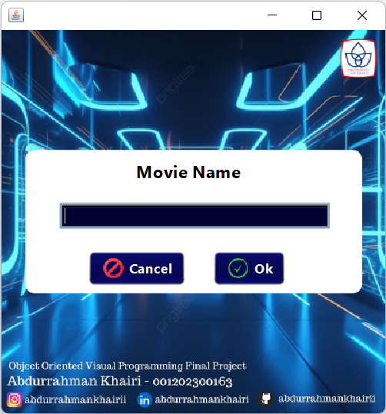

Image 4.3.8.1 View Request Movie Form

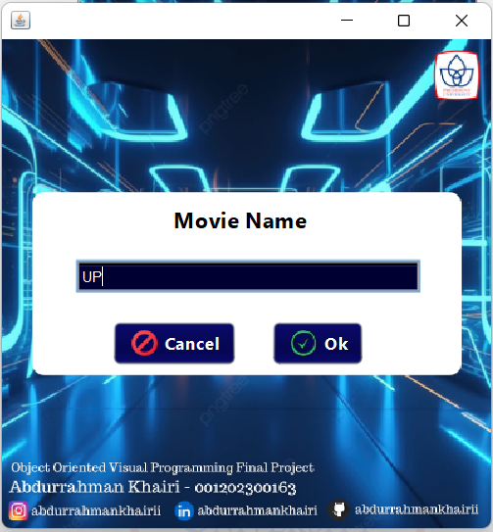

Image 4.3.8.2 Input Request Movie Form

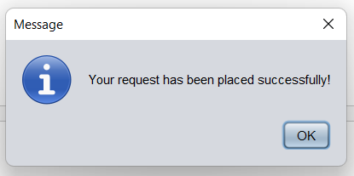

Image 4.3.8.3 Request Send Successfully

### LogOutUser

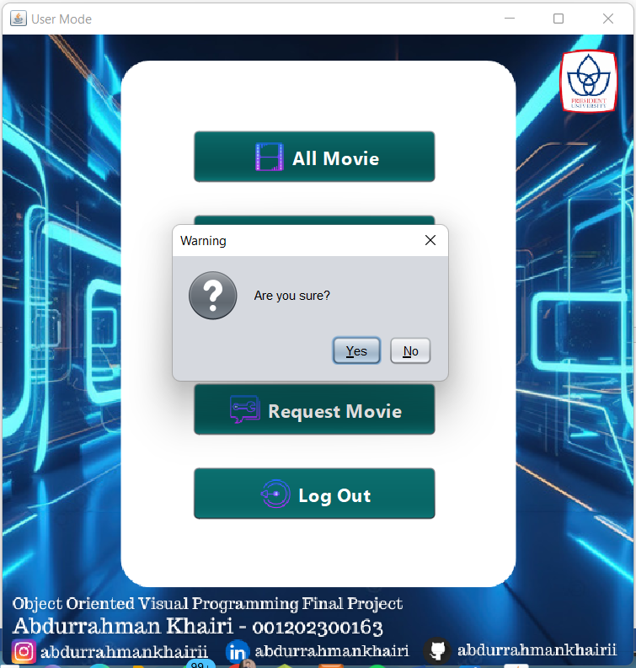

Image 4.3.8.4 LogOut User

# BAB V CONCLUSION

## CONCLUSION

In conclusion, the development of a movie ticketing application using Java NetBeans and a MySQL database offers a comprehensive solution to streamline the movie-watching experience. This user-friendly application empowers users to effortlessly book tickets, access detailed movie information, and discover a wide variety of films.

The application addresses the shortcomings of traditional ticketing methods by providing a convenient and efficient platform for booking movie tickets. NetBeans IDE's intuitive interface and Java's object-oriented programming capabilities facilitate a seamless development process, resulting in a robust and scalable application.

## BENEFITS

The implementation of this movie ticketing application offers a multitude of benefits for users, including:

1. **Simplified Movie Ticket Booking**: Users can conveniently book movie tickets from their devices, eliminating the need to queue at cinema counters.
2. **Comprehensive Movie Information**: The application provides users with detailed information about movies, including synopses, trailers, ratings, and user reviews, empowering them to make informed choices.
3. **Diverse Movie Selection**: Users can explore a vast selection of movies from various genres and countries, catering to diverse preferences and cinematic tastes.
4. **Enhanced User Convenience and Satisfaction**: By streamlining the booking process, offering rich movie information, and providing a diverse film selection, the application elevates the overall movie-watching experience for users.

## FUTURE RECOMMENDATION

Future enhancements can be explored to further improve the application's functionality and user experience. These may include:

1. **Integration with Online Payment Gateways**: Implementing secure online payment gateways will allow users to seamlessly purchase tickets within the application.
2. **Advanced Search and Filtering Options**: Adding advanced search and filtering functionalities based on genre, release date, director, cast, and user ratings will enable users to refine their movie searches and discover films that align with their specific preferences.
3. **Seat Selection Functionality**: Integrating seat selection capabilities will empower users to choose their preferred seats during the booking process.
4. **Personalized Recommendations**: Implementing a recommendation system based on user preferences and viewing history will personalize the movie discovery experience for users.
5. **Integration with Social Media Platforms**: Connecting the application with social media platforms will allow users to share upcoming movies, reviews, and recommendations with friends and family.

By incorporating these potential enhancements, the movie ticketing application can evolve into a comprehensive and user-centric platform, further transforming the way users discover, book tickets for, and enjoy movies.